DEVELOPMENT OF A LEARNING PATH RECOMMENDER SYSTEM BASED ON A KNOWLEDGE GRAPH
A PhD Thesis
By

Regha, Israel Oghenevwede
RUN/CMP/21/11491

Department of Computer Science
Redeemer’s University Ede, Osun State.

Supervisors: Prof. Arekete, S. A., Prof. Odim, M. O. &
Dr. (Mrs.) Oguntunde, B. O.

Table of Contents
Cover Page ……………………………………………………………
Table of Contents …………………………………………………….
Chapter 1: Introduction
  - Background of the study ………………………………………………
  - Statements of the Problem …………………………………………….
  - Aim and Objectives of the study ………………………………………
  - Overview of the Methodology …………………………………………
  - Scope of study …………………………………………………………
  - Significance of the study ……………………………………………….
  - Definitions of terms …………………………………………………….
  - Organization of the study

Chapter 2: Literature Review
  - Introduction
  - Recommender Systems
2.3 Limitations of Recommender Systems
2.4 Educational Recommender Systems
2.5 Learning Path Recommender Systems
2.6 Methods of generating LPRS
2.6.1 Knowledge Graphs
2.7 Related Works

Chapter 3: Methodology
3.1 Introduction
3.2 Requirements Gathering
3.2.1 Software Requirements
3.2.2 Hardware Requirements
3.3 System Design
3.3.1 Data Extraction Phase
3.3.1.1 Data Gathering
3.3.1.2 Data Description
3.3.1.3 Data Pre-processing
3.3.1.4 Data Validation
3.3.2 Knowledge graph Creation Phase
3.3.2.1 Concepts Extraction
3.3.2.2 Relationships Extraction
3.3.2.3 Integration of Graph Database
3.3.3 Learning Path Creation and Recommendation Phase
3.3.3.1 Learning Paths Creation
3.3.3.2 Learning Paths Recommendation
3.3.4 User’s Interface (GUI) Phase
3.4 Unified Modelling Language (UML)
3.4.1 System process Diagram
3.4.2 Use-case Diagram
3.4.3 Activity Diagram
3.5 Model Description
3.6 Functional Design
3.7 System Implementation
3.8 System Integration Evaluation
3.9 Deployment of the system
3.10 Maintenance of the System

CHAPTER 1: INTRODUCTION
  - Background of the study

The advents of web 2.0 technologies, which empower online users to create and distribute content at will (Chung & Kim, 2016) has led to the explosion of information and media contents on the web (Wilson, Lin, Longstreet, & Sarker, 2011). Also, with the increasing rate of digital technologies adoption by individuals and corporate organizations, the growth of data and information on the web will equally be on the increase (Wilson et al., 2011).

As a result of the massive amount of information on the web, accessing relevant and personalized online materials are increasingly becoming very difficult due to information overload (Tahmasebi, Gazvini, & Esmaeili, 2018). Some of the challenges posed by information overload to users includes, delays in accessing relevant and personalized resources (Urdaneta-Ponte, Mendez-Zorrilla & Oleagordia-Ruiz, 2021), psychological stress (Melinat, Kreuzkam & Stamer, 2014) and information confusion (Yang, Huan, Zhai, & Lin, 2021).

Natarajan, Vairavasundaram, Natarajan and Gandomi (2020) also posited that the web is being populated every moment to the point that human beings cannot deal with the vast amount of data manually or via traditional tools. Consequently, Recommender Systems (RS) were developed to assist users with fast and easy access to relevant and personalized materials from vast online resources (Urdaneta-Ponte et al., 2021).

Lalitha & Sreeja (2020) defined Recommender Systems, as computer programs which are capable of suggesting or predicting the most suitable items to users out of a vast number of alternatives based on certain predefined criteria. In other words, Recommender systems are software applications that support online users by identifying and suggesting the most relevant and personalized resources, based on their stated preferences.

Recommender Systems are applied across several domains such as ecommerce, entertainment, tourism, education among others. In the field of education, Recommender Systems also referred to as Educational Recommender Systems or E-learning Recommender Systems (ERS) (Rahayu, et al., 2023) are widely used due to the vast amount of online educational resources. Xu et al. (2021) remarked that as a result of the enormous educational resources online, learners are often confronted with several challenges such as cognitive overload, knowledge fragmentation, among others. These could lead to reduced attention span and low learning efficiency (Wei et al., 2021 in Wu et al., 2020; and Xu et al., 2021). Souabi et al. (2021), remarked that Recommendation Systems are the best way to assist learners manages the large volume of information and educational resources in order for the learners to make the best use of these resources to meet their learning objectives.

Thus, Educational Recommender Systems (ERS) are designed to support learners in accessing and managing diverse educational resources, while delivering appropriate content in a highly personalized and adaptive manner

(Souabi et al., 2021). Educational Recommender Systems are used to recommend educational items such as learning resources, learning styles, courses, peer learners, learning sequences, activities and learning pathways (Lu et al., 2015; Souabi et al., 2021; Troussas & Krouska, 2023 & Wei et al., 2021).

Several benefits of ERS have been identified in literature. According to Tahmasebi et al. (2018), recommendations improve learners’ learning path. Da Silva et al. (2022) remarked that learners’ motivation and academic performance could be improved by having access to timely and appropriate content through the use of ERS. Rahayu et al. (2022) also noted that, ERS helps to identified students with learning difficulties. Hence, personalized recommendations can be generated that can adapt to the learner’s learning peculiarity. Apart from the learners, Urdaneta-Ponte et al. (2021) noted that ERS could be used beneficially by teachers, school administrators, academic advisors/counsellors and researchers.

Despite these and other potential benefits of ERS, certain limitations in existing studies have been identified. Da Silva et al. (2022) and Souabi et al. (2021) noted that the major focus of studies in this domain, have been towards successful development and implementation of functional ERS, improvements on accuracies of recommendations and users’ satisfaction. Similarly, Ouadoud, Chkouri, Nejjari, & El Kadiri (2017) observed that most studies evaluating RSs, focus mainly on their functional aspects while neglecting many vital aspects such as security, maintainability, among others. This according to them has led to low adoption of RSs in education.

Deschênes (2020) remarked in her systematic review study that, existing studies did not identify any clear trend with regards to tasks accomplished by existing ERS. Urdaneta-Ponte et al. (2021) and Da Silva et al. (2022) equally observed that most recommendations from existing Recommender Systems were not targeted towards any specific knowledge areas. Similarly, Da Silva et al. (2022) posited that most recommendationtions do not provide pedagogical sequencing that supports self-directed and self-paced leraning.

Da Silva et al. (2022) and Souabi et al. (2021) also reported a dearth of studies in non-formal and informal learning noting that most of studies in the field of educational recommender systems are targeted towards formal learning. Zayet, Ismail, Almadi, Zawia and Nor (2022) equally remarked that most studies on ERSs focused more on higher education of learning. Supporting this view, Urdaneta-Ponte et al. (2021) emphasized the need for future studies to cut across all levels of education. Rahayu et al. (2022) remarked that most e-learning Recommender Systems are tailored towards recommending learning objects. The study added that recommendation of other learning items such as learning paths, peers and feedbacks are still emerging.

Machado and Boyer (2021) posited that ERSs should not only be tailored towards recommending items based on learner’s interest but also on attainment of the learner’s learning goal. Da Silva et al. (2022) also suggested that, studies that focused on educational recommenadtion systems which could guide a learner through a learning path to specific knowledge acquisition and support self-directed learning are desirable.

In addition to the above identified gaps, existing studies on ERS also revealed that most recommender systems are designed to offer recommendations based on course selection to learners, as seen from the studies by Okeoma and Mgbeafulike (2019), Morrow et al. (2020). Similarly, most recommendations based on Learning Pathways, focuses more on creating and recommending learning paths to learners using either just a chapter/topic from a course as from the study by Liu et al. (2023) and Shi et al. (2020). However, studies on the LPRS based on a whole syllabus are not common. Finaly, Siren and Tzerpos (2023) also observed that learning paths creation and recommendations based on Open Educational Resources (OER) are equally scarce.

In light of these identified gaps, this study aims to develop a Senior Secondary School Syllabus-based Learning Path Recommender System (LPRS), constructed from Open Educational Resources (OER) data using Knowledge Graph driven technique.

1.2 Statement of the Problem

Learning paths Recommender Systems is an emerging area of study in the domain of e-Learning (Rahayu et al., 2023), with several studies already carried out and many are still ongoing as seen from reviewed literature. However, existing studies on the implementation of Learning Path Recommender Systems (LPRS) grounded in a standardized syllabus, particularly within the secondary school context, remain limited, as highlighted by Da Silva et al. (2022), Urdaneta-Ponte et al. (2021) and Zayet et al. (2022).

Therefore, this study proposes the development of a Learning Path Recommender System based on the West Africa Senior School Certificate Examination (WASSCE) Mathematics syllabus using knowledge graph driven approach. The proposed software will be referred to as- Senior School Mathematics Learning Path Recommender System (SSM-LPRS).

1.3 Aim and Objectives of the study

The aim of this study is to develop a Learning Path Recommender System (SSM-LPRS), that will generate learning paths (routes) and offer sequential recommendations of learning objects to users based on the West Africa Senior School Certificate Examination (WASSCE) Mathematics syllabus using data from Open Educational Resources (OERs).

The specific objectives of the study are to:
- design a Learning Path Recommender System based on knowledge graph methodology;
- implement the system developed in (i); and
- evaluate the performance of the system using Usability metrics.

  - Methodology
The study adopts the Waterfall model of software engineering development methodology in the development of the proposed system. The choice of the model is because of its clarity and simplicity. The development of the proposed system involves four (4) distinct phases adapted from the studies by Siren and Tzerpos (2022), Shi et al. (2020) and Xu et al. (2021).

The phases are:
- Data extraction phase;
- Knowledge Graph creation phase;
- Learning Paths creation and Recommendations phase;
- Users’ interface phase.
Using a modular design approach, each of these phases will be developed separately one after the other and afterwards integrated and implemented to realize a functional Learning Paths Recommender System- the SSM-LPRS.

  - Scope of the study

This study focuses on the development of a Learning Path Recommender System (LPRS) for Senior Secondary School students (SS1–SS3) in Nigeria, using the WASSCE Mathematics syllabus. The system leverages Open Educational Resources and adopts a knowledge graph approach to represent domain knowledge.
Specifically, the scope of the proposed System is confined to the following:
- To generate learning paths for learners;
- To recommend personalized learning resources (learning objects) for individual learner;
- Senior Secondary School (SS¹-SS³) students in Nigeria are primarily the targeted users;
- The learning resources for the study is based on the content and scope of the West African Senior School Certificate Examination (WASSCE) Mathematics Syllabus;
- The learning resources are sourced from Open Educational Resources (OER) and other free learning websites.

1.6 Significance of the study
The proposed system is expected to provide, among other benefits, the following:
- To increase the availability of syllabus-based e-Learning resources, thereby minimizing disruptions to academic programmes occasioned by challenges such as pandemics, insurgencies, etc;
- To increase the availability of syllabus-based e-Learning resources which will enhance the quality of education at all level and help to mitigate the declining standard of educational;
- To promote autonomous learning among secondary school students;
- To raise the standard of students’ performance in mathematics at SSCE level;
- To address the shortage of mathematics teachers and instructional resources;
- To encourage the development of similar syllabus-based e-Learning in other subjects;
- To support formal and informal education; and
- To provide useful feedbacks to students, teachers, school administrators and parents.

  - Operational definition of Terms

- Adaptive Learning: Adaptive learning is an instructional technique that employs algorithms and data to automatically adjust education content, difficulty level, and sequence in real time based on a learner’s performance and behaviour.

- Data Mining: Data mining is the process of discovering correlations or patterns among entities in large databases (Prasad & Raman, 2017).

- Concepts/Entities/Objects: The terms concepts, entities and objects are used synonymously in this study to refer an identifiable piece of information or knowledge point such as learning objects, topics, and among others.

- Embedding: In natural language processing (NPL), the word embedding is a technique for converting textual data into vectors in a multi-dimensional space. In other words, embedding algorithms are used to transform words into numerical representations (vectors). Each word is mapped to a vector and words with similar meaning are positioned close together in the vector space. The use of embedding techniques in NLP problems is essential because NPL models cannot process textual data in their raw state. Word embedding helps in classification or clustering of data and reveals sematic and syntactic relationships between words (Siren & Tzerpos, 2022).

- Information confusion: This is an effect of information overload, when an individual is unable to decide on the most appropriate information to accept or act upon as a result of too much of similar or ambiguous information (Dang, 2020; Yang et al., 2021).

- Information overload: This is the feeling of too much information to be processed for the cognitive capacity of a person (Melinat et al., 2014). Information overload makes the amount of information in the social media far greater than what it can carry.

- Learning Goal: A learning goal also known as the target learning object is defined as what a learner intends to learn within a given session (Shi et al., 2019).

- Learning Objects (LOs): Learning Objects are small digital units of a learning course that can be reusable in various learning contexts (Bouihi & Bohaj, 2019).
- Ontology: Ontology is defined as the explicit and formal specification or definition of terms/concepts and the logical relationship between them within a given knowledge domain (Alhawiti, & Abdelhamid, 2017). Ontology permits and facilitates the formal representation of the dependencies between different units of a system (Brink & Touahria, 2020).
- Personalized Learning: This is an educational concept in which instruction, content, pace, and learning pathways are tailored to meet the unique needs, abilities, preferences, and goals of each individual learner.
- Semantic web: The semantic web is an improvement on the existing web. However, unlike the existing web which was built on machine readable technology, the semantic web, is built on the principle of ontology and machine understandable technologies (Alhawiti, & Abdelhamid, 2017).
- Sequence: Wang et al. (2021) defined a “sequence as a list of items with clear order”.

- Time step (t): A time step refers to a single position in the sequence where the Gated Recurrent Units (GRUs) model processes an input x_{t}​, updates its hidden state, and passes information forward. A time step is one position in a sequence where the GRU processes an input.

1.8 Contribution to Knowledge
This study focuses on developing and implementing a Learning Path Recommender System based on the WASSCE Mathematic syllabus
The study will contribute to knowledge by addressing, some of the gaps identified in reviewed literatures:
- The system will be developed to offer LP recommendations on a specific knowledge area (SSCE mathematics) in response to Urdaneta-Ponte et al. (2021) and Da Silva et al. (2022) who observed that most recommendations from existing Recommender systems were not targeted towards any specific knowledge areas;
- The proposed system is a LPRS which will be built to sequentially, recommend learning objects that will satisfy a learning goal (SSCE mathematics syllabus), this is in response to the gap identified by Machado and Boyer (2021) that recommendations should in addition, satisfy the learning goal of a learner and lead towards the attainment of specific knowledge (Da Silva et al., 2022).
- The proposed system will be implemented in the context of a secondary school maths syllabus. This will address the gap identified by Zayet et al. (2022), that most studies on ERSs focused more on higher education of learning instead of other levels of education (Urdaneta-Ponte et al., 2021).
- The system is developed based on a complete mathematics syllabus for senior/high school, hence it will in addition serve as a courseware that can be used to support e-Learning.

1.9 Organization of the project
This study is organized into five chapters, a reference list and an appendix section. A brief overview of each is presented below:
Chapter 1 is the introduction of the entire study. It gives a general overview of the entire study and consists of nine sub-headings. The chapter begins with the background of the study and highlighted the gaps in literature which serves as the inspiration for embarking on the study. The chapter also includes the statement of the problem, aim and objectives of the study, the methodology to be used, the scope and significance of the study. The chapter concludes by considering operational definitions of some technical terms used in the study, the expected contributions of the study to knowledge and how the study is organized.

Chapter 2 is dedicated to reviewing existing literature relevant to the study with focus on key concepts central to the study. The concepts include Recommender systems, Learning Paths, Learning Paths Recommender Systems, Knowledge graphs, Syllabus and Open Educational Resources.

Chapter 3 describes the research methodology adopted for the development of the proposed system, including the algorithms and processes employed across its various stages of development. The system will be developed using the waterfall software development model. In addition, the chapter also capture in details the first two phases of the waterfall model which are- requirements gathering and analysis phase and the design phase. The design phase is structured into four main phases which are- data extraction, knowledge graph construction, learning path generation and recommendation phase, and the users’ interactive phase.
Chapter 4 encompasses the remaining four phases of the waterfall model of the system development life cycle. These phases include- the implementation phase, integration and testing phase, deployment phase and the maintenance phase. The chapter begins by highlighting how the system will be implemented by presenting in details, how each design phase will be realized using relevant software tools. This is followed by integrating the various components of system together in order to realize a complete functional system (SSM-LPRS). The system is consequently deployed and evaluated. The results will be analyzed and discussed. Finally, issues of maintenance will be addressed accordingly.

Chapter 5 concludes the study by giving a concise summary of the entire work. Challenges encountered will discussed and recommendations will be presented.

References: A reference list consisting of all the authors cited in the study are organized using the 6th edition of the APA referencing style.

Appendix Section: This section presents the program source code used to implement the various components of the system, along with other documents relevant to the study.

CHAPTER 2: LITERATURE REVIEW
2.1 Introduction

This chapter presents a detailed and comprehensive review of some existing studies that are relevant to this study. Specifically, the review focuses on key concepts such as Recommender systems (RS), Educational Recommender Systems (ERS), Learning Paths, Learning Paths Recommender Systems (LPRS), Knowledge graphs, Open Educational Resources (OERs) and the West Africa Senior School Certificate Examination (WASSCE) Syllabus.

2.2 Recommender Systems

Recommender Systems is the centre focus of this study. In this section, attention is given to discuss some key concepts about Recommender Systems as seen from reviewed studies. Some of these concepts include, definitions, types, applications and limitations of Recommender Systems.

Recommender Systems also known as Recommendation Systems have been defined differently by different scholars and yet, its meaning, scope and application keep expanding (Rahayu, Ferdiana & Kusumawardani, 2023). Lalitha and Sreeja (2020) defined Recommender systems as computer programs which are capable of suggesting or predicting the most suitable items to users out of a vast number of alternatives based on certain predefined criteria. Khalid, Lundqvist and Yates (2022) also defined Recommender System as an intelligent filtering software that assists users to filter out items based on their preferences from large number of products or services. In a nutshell, Recommender Systems are special type of retrieval and filtering software, developed to assist online users overcome the problem of information overload on the internet by offering relevant and personalized suggestions that best suits users’ needs and preferences out of the plethora of online resources.

As part of its benefits, Recommender Systems help users to save time, energy and reduced distraction while working online (Xu et al., 2021). Also, by providing timely and relevant recommendations that best suit user’s needs, Lalitha and Sreeja (2020), and Souabi et al. (2021) observed that Recommender Systems could enhance users’ experience. Furthermore, Recommender Systems also make it easier for users to obtain related information even for items they have little or no knowledge about (Khalid et al., 2022).
Describing how Recommender Systems works, Vaidhheli and Suchithra (2018), noted that Recommender systems have three basic components, which are:
- Users;
- Items;
- Ratings.
Similarly, Deschênes (2020) stated that Recommender Systems perform two major tasks in the recommendation process:
- First, it predicts a value of how much a user appreciates a given resource. This value is rated on scale (example, by number of stars);
- Secondly, the RS will then recommend N- numbers of resources/items that are equivalent to the rated value.

2.2.1 Types of Recommender Systems

There are different types of Recommender systems. The three oldest RSs referred to in several studies are- Collaborative Filtering (CF) Content-Based (CB) and Hybrid Recommender systems (Deschênes, 2020). However, more recent studies have identified other types of Recommender systems. These include- Knowledge-Based, Context-aware, Fuzzy set-based, Graph-based, Machine learning-based, Social Networking-based, among others (Rahayu et al., 2023; Souabi et al., 2021 & Urdaneta-Ponte et al., 2021). Some of these Recommender systems are presented and discussed below:
- Collaborative filtering techniques: In Collaborative filtering, recommendations for an active user are generated by analysing the preferences of other users who have previously shown similar interests and choices (Tahmasebi et al., 2018). The Collaborative filtering model works by collecting and analysing data on a user’s behaviour, activities and preferences and matching them with other users with similar preferences and consequently suggesting items liked by those other users to the active user based on similar preferences (Troussas & Krouska, 2023 & Urdaneta-Ponte et al., 2021). This category of Recommender systems is built on a user-user relationships (Xu et al., 2021). One advantage of CF is that it is not content dependent; hence it can be used to provide recommendations to a community (peers).

- Content-based (CB) filtering technique: This category of Recommender systems, recommend items based on the user’s historical content. This implies that, recommendations by CB algorithms are made based on items the user had preferred in the past (Tahmasebi et al., 2018). The system will consequently suggest items similar to items the users had selected or rated in the past. This category of Recommender systems is built on a user-items relationships (Xu et al., 2021). The major advantage of the CB is that it is able to recommend personalized to resources to users (Maged et al., 2018).

Hybrid filtering techniques: Hybrid Recommenders are built by combing the algorithms of the other techniques (CB & CF) in various ways to create a desired Recommender Systems. Hybrid Recommender Systems, are designed to overcome the drawbacks of the other techniques (Tahmasebi et al., 2018). It is important to note that most of the recommendation approaches are hybridized methods as seen from the studies by Da Silva et al. (2021), Souabi et al. (2021) and Urdaneta-Ponte et al (2021).

2.2.2 Application of Recommender Systems

The application of Recommender Systems spans several domains. Below are some of the areas where the applications of Recommender Systems have been acknowledged in literature:
- Ecommerce: Recommender Systems are used by companies like Amazon to offer personalized goods and services to their consumers (Natarajan et al., 2020; Troussas & Krouska, 2023).
- Entertainment: Recommender Systems are used in the selection of Movies, music, News articles, social networking sites, etc. (Troussas & Krouska, 2023; Vaidhheli & Suchithra, 2018).
- Tourism: Recommender Systems are used in the tourism to retrieve personalized locations and other tourist products (Brink & Touahria, 2020)
- Education: In education, Recommender Systems are used to recommend items such as learning resources, courses, peer learners, learning sequences and activities (Souabi et al., 2021; Wei, et al., 2021).

    - Limitations of Recommender Systems

Recommender systems also exhibit certain limitations that can negatively impact the quality and reliability of their recommendations (Natarajan et al., 2020; Stitini et al., 2022; Tahmasebi et al., 2018; Siren & Tzerpos, 2023). Some of the commonly identified limitations of recommender systems include data sparsity, the cold-start problem, the grey sheep issue, and overspecialization. Natarajan et al. (2020) and Tahmasebi et al. (2018) observed that while data sparsity, cold start and grey sheep are mostly associated with Collaborative filtering Recommender Systems; the problem overspecialization is a majorly associated with Content-based Recommender Systems. These challenges are briefly discussed below:

- Data sparsity: This problem arises when the number of rated items of a particular dataset by users is very few compared to the size of the dataset. This implies that, the resulting user-item matrix consists of mostly zero entries or empty (null) cells, leading to poor coverage of desired items, inaccurate predictions and unreliable recommendations (Natarajan et al., 2020).

- Cold start: Cold start is a problem that is due to lack of sufficient information or no history about new users (user cold start) or no rating on new items (item cold start) (Natarajan et al., 2020). This problem happens when new users do not have adequate interaction with the system or they just have few ratings of the new items leading to poor personalization or irrelevant recommendations to users (Srivastava, Bala & Kumar, 2019).

- Grey-sheep: Grey-sheep is problem mainly associated with Collaborative filtering Recommender Systems, in which preferences of some few users (known as the Grey-sheep) do not match the preferences of the majority of users in the community (Tahmasebi et al., 2018). Srivastava et al. (2022) noted that Gray-sheep are users that have low coefficient correlation with the majority of the users. This disparity in preferences according to the authors leads to poor recommendations to users and affects the efficiency of the Recommender Systems negatively.

- Over-specialization: This challenge reflects the weakness of a Content-based Recommender system’s inability to recommend new items that are outside the range of mostly rated items based on user’s past historical preferences. Consequently, new useful items outside the already established range might not be suggested to the user and this could affect user’s interests in the system with time (Stitini et al., 2022).

Siren and Tzerpos (2023) noted that these limitations are more prevalent in traditional recommender systems; however, they can be mitigated by employing ranking algorithms that prioritize recommendations based on diverse criteria, such as assigning weights to specific tags.

2.3. Learning Paths

Learning Paths (LP), also referred to as Learning Pathways, constitute another key concept in this study. This section of the review focuses on its the meaning, types and some of its educational benefits. By definition, Shi et al. (2019) defined Learning Path as a sequence of learning objects that are generated to help learners achieve a specific learning goal. Iatrllis et al. (2019) and Rayahu et al. (2023) defined Learning Path as a learning route that guide learners towards the attainment of a specific learning objective. Gao et al. (2021) noted that Learning Paths provide personalized guidance aimed at enhancing learners’ performance in e-learning systems. In other words, Learning Paths are structured educational routes or tracks that guide learners through a course of series of courses (program) thereby helping them to achieve specific learning goals efficiently and systematically.

Learning Paths involves the breaking down of difficulty topics into smaller manageable units, allowing learners to progress systematically from foundational concepts to more advanced topics. Learning Paths can be tailored to various subjects, from technical skills to soft skills, and are essential in both academic and professional training. Rahayu et al (2023), observed that Learning Paths has been used in studies either as course sequencing within a given program or as learning objects sequencing within a particular course.

Siren & Tzerpos (2022) identified two distinct learning path models. These according to them are:
- Standard linear models
- Metro map models
According to the authors, the LP standard linear models represent a linear route which a learner transverse from a particular point to another point in the learning path in order to arrive at a learning goal. Similarly, the authors refer to the metro map model as a learning route with multiple predefined routes which a learner transvers to arrive at a learning goal. These types of learning models are illustrated in Fig. 2.1. As shown in fig. 2.1, each node represents a knowledge point (learning object) and the edges shows relationship.

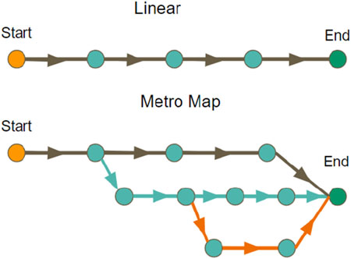
Fig.2.1: Learning path models (Siren & Tzerpos, 2022)

2.4 Learning Path Recommender Systems (LPRS)

Learning Path Recommender Systems (LPRS) constitute the core focus of this study. This section of the review examines the meaning of Learning Path Recommender Systems as presented in the literature. Rahayu et al. (2023) observed that Learning Paths Recommender Systems as an aspect of Educational Recommender Systems (ERS) is still emerging and growing very fast. It is gaining much attention among scholars in the domain of e-Learning due to the increasing popularity of e-Learning and the application of big data in education (Machado & Boyer, 2021).

Machado and Boyer (2021) defined Learning Paths Recommender Systems as a system that recommends Learning Paths to users in accordance with their preferences, learning goals and also satisfies the requirements of a curriculum. Nabizadeh et al. (2020) also described a Learning Path System as the implementation of a curriculum. In other words, a Learning Path Recommender System is an intelligent educational system that recommends a personalized sequence of learning resources to learners based on their learning needs, goals, preferences, or curriculum requirements. The primary aim of a Learning Path Recommender System is to guide learners through the most appropriate learning pathway so they can achieve specific learning objectives effectively and efficiently.

It is important to note that from the definitions of Learning Paths Recommender Systems given by Machado and Boyer (2021), Nabizadeh et al. (2020) and Rahayu et al. (2023), it is clear that curriculum/syllabus is an integral component of a Learning Paths Recommender System. This implies that LPRS are designed to be implemented within the scope of a given curriculum or syllabus.

Different reasons for developing Learning Paths Recommender Systems have been advanced by different authors. Gao et al. (2021) observed that due to the rapid growth of online learning resources, the task of planning learning paths using manual approach by educational experts and teachers is increasing becoming burdensome and difficult to achieve manually. Hence, the automation of learning paths generation for individual learner became necessary. Similarly, Liu et al. (2023) remarked that the aim of a learning path recommender system, is to suggest reasonable learning paths that support learners to achieve a compressive and reliable learning. Supporting this view, Ovtšarenko (2023) equally noted that, properly organizing the sequence of learning objects to generate a well-defined learning path can enable e-learners to achieve their learning objectives efficiently and systematically.

2.4.1 Methods of Generating Learning Paths and Learning Paths Recommendations for learners

Different methods of generating learning paths and recommendations for learners have been identified. Gao et al. (2021) stated that, the objective of a learning path generator is to create an optimal sequence of knowledge units for learners based on their individual characteristics, thereby providing effective guidance and enhancing learning efficiency.

Ovtšarenko (2023) identified three major methods that can be used to generate learning paths recommendations for learners. These methods according to the author are:
- Artificial Inteligience (AI) methods;
- Rule-based methods; and
- Statistic-based methods.
Similarly, Gao et al. (2021) also identified three categories of methods for generating learning paths for learners. According to the authors, these methods are based on:
- Characteristics of learners and knowledge units,
- Swarm intelligence; and
- Knowledge map/graph.

2. 5 Knowledge Graphs

Knowledge Graphs (KGs) are structured representations of knowledge that model entities and the relationships between them (Diao et al., 2022). They serve as a form of knowledge base representation, enabling information to be organized in a visual and interpretable graph format; simplifying complex information into nodes and relationships that are easily understandable. Shi et al. (2020) and Wang et al. (2022) defined Knowledge Graphs as a semantic network of entities (concepts) linked together by certain relationships. Knowledge graphs are used to represent entities and the relationship between them in a structured or graphical form that can easily be understood by users (Guo et al., 2025; Yang et al., 2021) as shown in Fig. 2.2. Wang et al. (2024), also stated that Knowledge Graphs represent entities and their relationships concisely, hence making it easy to organize, manage and use vast amount of information on the internet in the most effective way.
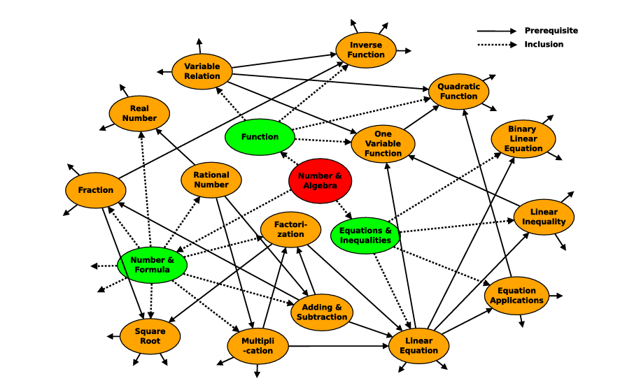
Fig. 2.2: A sample of a Knowledge Graph (Chen et al., 2018).
2. 5.1 knowledge representation in Knowledge graph

In knowledge graphs, concepts are represented by nodes while the edges represent the semantic relationship between the nodes (Wang et., 2022). The concepts and relations in Knowledge Graphs are often represented or stored in the form of triples- (head entity, relation, tail entity) or simply as (h, r, t) (Wang et., 2022, Wang et al., 2024) as shown in Fig. 2.3. Some notable knowledge graphs used across several applications are DBpedia, YAGO, Freebase, WordNet, and Google Knowledge Graph (He et al., 2023; Wang et al., 2024).

On knowledge graphs dimensionality, the study by, Shi et al. (2020) provided evidence that multidimensional Knowledge Graphs offers better recommendations and more user friendliness than single dimensional Knowledge Graph algorithms. The authors noted that single dimensional knowledge graph cannot effectively create sufficient relationships among learning objects since in a syllabus-based learning environment, relationships transverse levels of learning.

Relation 1
Head_entity1

Tail_entity 1
Head_entity2

Relation 2 Relation3 Relation 4
Tail_entity3

Tail_entity2

Fig 2.3: Triple representation of entities and relations (Head_entities, Relation, Tail_entities) in knowledge graphs.

2. 5.2 Uses and Benefits of Knowledge Graphs

Several uses of Knowledge Graphs have been identified in existing studies. Some of which include, questions answering (QA) systems, social media data mining, reliability measurement, education, dialogue generation, among others (He et al., 2023; Wang et al., 2022; Wang et al., 2024). Yang et al. (2023) also observed that large-scale knowledge graphs are increasingly being integrated into various applications, including search engines, news platforms, and advertisement systems.

In the field of education, Knowledge Graphs are fast becoming a major transformative and indispensable tool with capacity to reshape the future of education (Abu-Salih & Alotaibi, 2024). It is important to note that since educational data often embody semantic information content, knowledge graphs prove vital for representing interconnected knowledge within educational contexts. Abu-Salih and Alotaibi (2024) identified four primary areas of applications of Knowledge Graphs in education. These according the authors are, adaptive and personalised learning, curriculum design and planning, concept mapping and visualization, semantic search and questioning answering. The authors added that, Knowledge graphs offer the potential to provide personalized, data-driven, and adaptive learning experiences.

Other notable uses of Knowledge Graphs include Learning Paths Creation (Chen et al., 2018; Gao et al., 2021) and development of Educational Recommender Systems (Liu et al., 2023; Shi et al., 2020; Troussas & Krouska, 2023; Xu z et al., 2021). Gao et al. (2021) noted that Knowledge Graph serves as an effective approach for capturing the features of domain knowledge and learning resources, thereby facilitating the generation of learning paths. Yang et al. (2021) observed that Knowledge Graphs are naturally good in expanding information about an entity and strengthening relationships between entities in a given knowledge domain. The authors added that Knowledge Graphs do not only provide a foundation for semantic reasoning but also enables the modelling of multi-hop complex relations and satisfy diverse learning needs (Shi et al., 2020).

Considering the benefits of Knowledge Graphs, Yang et al. (2021) remarked that Knowledge Graphs minimizes the problems of data sparsity and cold start by providing adequate information about the relationship between entities. Xu et al. (2021) also noted that Knowledge Graphs-based Recommender Systems offer better efficiency than the conventional Recommender Systems. The authors supported their argument by stating that, the relational database used by most conventional Recommender Systems (such as CF & CB) gets slower as the database gets larger and hence less efficient. Liu et al. (2023) equally observed that, Knowledge Graphs can identify learning paths accurately, removes knowledge fragmentation and information redundancy.

The obvious advantages of Knowledge Graphs as seen from many studies, serves as motivation and justification for adopting the knowledge graph-based methodology in this study for the development of the SSM-LPRS.

2.6. Related Works
This section of the literature review focuses on some existing studies on Learning Path Recommender Systems closely related to this study.

S/N | Author & Year | Title of paper | Problem(s) Identified | Methodology | Results | Research Gap / Future study
1. | Shi et al. (2020) | A learning path recommendation model based on a multidimensional  knowledge graph (KG) framework for e-learning. | The researchers observed that: Existing studies on LPRS using knowledge graph approach, are built to connect LOs together based on a single relationship.  Thus, these LPRSs cannot generate diverse LPs which limit users’ access to diverse learning needs. | Mixed Methods:  Knowledge graph, Graph traversal & Quantification algorithms | 1. A successful design of a multidimensional KG model of a LPRS with multiple relationships between learning objects and can generate different learning paths for different learning needs for users,  2. Experimental results showed that the model is more efficient in generating more suitable LP recommendations than existing algorithms. | The success rate of generating LPs and users’ satisfaction decreases with increasing number of relationships between LOs increases. Thus:  The study suggests that future work should focus on improving success rate of generating LPs with complex relationships.
2. | Saito et al. (2020) | Learning Path Recommendation System for Programming Education Based on Neural Networks | The researchers observed that inadequate instructional materials and the shortage of skilled teachers constitute major challenges to the teaching of computer programming. | Mixed methods:  Ability Chart,  Clustering analysis and LSTM | Focus on finding similar user for recommendations, produced an unfit recommendation output due to insufficient data of the target users. | Proposed ﻿neural ﻿networks﻿ should ﻿be ﻿trained ﻿with ﻿di-fferent﻿ hyper-parameters﻿ and﻿ models.  Method﻿ for ﻿evaluating ﻿recommendations﻿ for ﻿real﻿ learners﻿ should be ﻿investigated ﻿by ﻿considering﻿ the﻿ distance﻿ between ﻿elements﻿ on ﻿the ﻿learning ﻿path
3 | Gao et al. (2021) | Learning Path Generator Based on Knowledge Graph | The burden of manually planning Learning Paths is increasing due to increase in learning resources | Mixed methods:  Topological Ranking Algorithm and  Ant Colony Optimization | Experimental results revealed that the learning path generated in the study is comparable to leaning paths manually constructed by experts. Hence could be adopted in creating learning automatically for learners. | There was no suggestion by the authors for further study
4. | Xu et al. (2021) | Development of Personalized Learning Resources Recommendation System Based on Knowledge Graph | The researchers noted that: conventional RSs (CB & CF) uses relational databases which gets slower as the database gets larger with more tables and hence less efficient.  Also, conventional RSs depend on historical data for recommendations, absence of which leads to less accurate recommendations. | Software Engineering methodology | A curriculum-based knowledge graph RS with two types of recommendation algorithms was successfully developed to offer personalized learning resources to users | The study recommended an implementation of the new software and perform data analysis to determine the level of accuracy and efficiency offer by the two recommendation algorithms.
5. | Liu et al. (2023) | Design of a Learning Path Recommendation System based on a Knowledge Graph | The study observed that current e-Learning platforms have the problem of:  resource overload,  lack of clear learning routes, and  does not support autonomous learning | Mixed- methods:  Knowledge Graph,  &  Particle Swarm Fusion algorithm | The authors revealed a successful design of a functional LPRS based on KG.  The system provides a structured and reasonable LPs to the learners unlike previous platforms;  The system also provides feedbacks to learners and teachers | The authors suggested the need for further studies ways to adapt the new system to other disciplines
6. | Troussas, & Krouska (2023) | Path-Based Recommender System for Learning Activities Using Knowledge Graphs | The study identified that there has not been sufficient integration of knowledge graph-based recommender systems into e-learning settings. | Path-based Knowledge Graph method | The authors successfully developed LPRS based on Knowledge Graph integrated into e-learning environment using students learning activities | The study used only the path-based method of generating LPRS using knowledge.  The study suggests using other methods (embedding and Unified methods)

CHAPTER 3: METHODOLOGY

3.1 Introduction

The proposed system is intended to be developed using the waterfall model of software engineering development methodology. The waterfall software development model is a structured, sequential and linear approach Pargaonkar (2023). The model consists of six major phases, which are: Requirement Analysis, System Design, Implementation, Integration & Testing, Deployment and Maintenance as shown in Fig.3.1. Some of the advantages of this model include: Clearly structured phases, comprehensive documentation, ease of management, clear deliverables and suitability for small projects (Pargaonkar, 2023). These advantages make this model a suitable choice for this study.

Requirement
Analysis

Design

Implementation

Integration &
Testing

Deployment

Maintenance

Fig.3.1: Waterfall Software development Model

3.2 Requirements Analysis Phase

In this initial phase of the software development life cycle (SDLC), needs analysis on the proposed system was carried out to identify in details, the requirements needed to successful develop a system that will meet the aim and objectives of the project in line with the study by Kramer (2018). These requirements include functional and non-functional requirements. Functional requirements, defines what the system is expected to do and the features that will enable users to perform the required tasks the system is built to perform. On the other hand, non-functional requirements deal with how well the system is expected to perform its specified tasks with consideration to reliability, efficiency and usability.

The main focus of this phase is to determine software and hardware requirements needed to achieve a successful development of the Learning Path Recommender System. These are discussed as follows:
3.2.1 Software Requirements
To successfully develop the Learning Path Recommender System, several software tools were utilized at different stages of the system development; beginning with data scrapping, pre-processing of data collected, graph modelling, paths creation and generation of recommendations. Some of the major software resources used in this study includes the following:
- Programming Language: Python 3.10+ was the primary programming language used for data model development.
- Application Programming Interface (API): The Oxylabs Real-Time Crawler API was used data scrapping tool
- Libraries and Frameworks: Libraries, modules and frameworks are pre-written reusable codes whose functionality can be called and incorporated in the development process of a system. Some of the reusable codes incorporated into the of development of this system are listed in table 3.1.
- Integrated Development Environment (IDE): The environment used for the development of the system consists of the following tools- Jupyter Notebook, VS Code and Venv for creating virtual environments to handle dependencies.
- Storage Format: Data gathered and processed for the study will be stored in. json, .csv and. graphml formats.

Table 3.1: Libraries, modules and Frameworks
Reusable Codes | Type | Purpose
Requests | Library | For sending API calls to Oxylabs Real-Time Crawler
Pandas | Library | For tabular data manipulation and export to .csv
Json | Library | Parsing and formatting JSON data
Re | Module | Regular expressions for keyword and text cleaning
MLxtend | Library | Supports association rule mining in prerequisites extraction
NLTK | Library | For text normalization and keyword extraction
NetworkX | Library | For constructing and visualizing the graphical compo
PyTorch | Framework | Supports GRU in data extraction and classification
Scikit-learn | Library | For similarity scoring and basic recommendation logic
Pyvis | Library | For graph plotting and visualization
Flask | Framework | For building web-based user interfaces

    - Hardware Requirements
The following are some of the hardware components required for the development of the software.
- Operating System: Windows 10, 64-bit system
- Processor: Intel Core i7, 5.40 GHz
- RAM: 16.00 GB
- Hard Disk: (SSD) 500 GB

  - System Design
The system design phase in SDLC of the system, is aimed at defining and establishing the technical and functional details of the proposed system based on the specified requirements. The development of a Learning Path Recommender System based on Knowledge Graphs typically involves several complex yet distinct phases (modules), as highlighted in studies by Siren and Tzerpos (2022), Shi et al. (2020), and Xu et al. (2021), among others. The development of the SSM-LPRS model, is structured into four (4) main phases, adapted from the frameworks of the studies by Liu et al. (2023), Siren and Tzerpos (2022), Shi et al. (2020), and Xu et al. (2021). These phases are:

- Data Extraction Phase;
- Knowledge Graph Creation Phase;
- Learning Path Creation and Recommendation Phase;
- Users’ Interface Phase.

To achieve a fully developed and functional SSM-LPRS, each of these phases will first be developed separately and afterward, are integrated in to a single functional system, illustrated in Fig.3.8. The procedure for the development of each phase is hereby presently as follows.

3.3.1 Data Extraction Phase
The data extraction phase is the first major phase in the development of the proposed system (SSM-LPRS). Liu et al. (2023) stated that data and entity extractions are the foundation for the development of a knowledge-based learning path recommender system. Data extraction is the process of gathering and processing relevant data to be used for the development of a system from different sources. In line with the study by Siren and Tzerpos (2022), data extraction task in this study includes: data gathering, data pre-processing and data validation. These tasks are discussed as followings. The sequence diagram for the data extraction process is given in Fig. 3.2.

3.3.1.1 Data Gathering

Data for the study was sourced from some Open Educational Resources (OERs) websites and other online educational websites. Data extraction was achieved through the use of Oxylabs Real-Time Crawler API. Oxylabs is a high-performance web scraping tool, which provides a powerful and scalable API that enables structured data extraction from various web sources, including search engine results.

Data were scrapped from several search queries using the following key words:
- Topics: Resources were searched on a topic-by-topic basis in accordance with the contents of the WASSCE Mathematics syllabus.

- Grade Levels: Grade levels used to search for topics include WAEC/NECO SS1–SS3, Grades 10–12 (USA, High School) and Key Stage 4 or KS4 (UK, Senior/High School).

- Equivalent syllabus: Two additional Syllabi used in this study include the Syllabus for the United States of America (USA) High school (Grades 10-12) and that of the United Kingdom (UK) High/ Senior School Key stage 4 (KS4) syllabus. This was done so as to gather adequate data for the dataset.

3.3.1.2 Description of the Data

Data extracted for this study consist of the following data types:
- Textual Data: Textual data are in the form of words used to represent or convey meaningful information. Textual data are used in this study to introduce topics, present lessons, give explanations, instructions, and comments.
- Numerical Data: Numerical data type basically consists of numbers and numerical values. In this study, numerical data also include formulars, symbols, notations and other measurable quantities. Numerical data are used in this study are used to perform all mathematical calculations, statistical analysis and express all equations.
- Video Data: A video data type refers to data that contains moving visual images, usually combined with sound. It is used to represent recorded or streamed visual content. In this study, videos of lessons, tutorials and quizzes will be used as instructional content.
- Audio Data: An audio data type refers to data that is presented in auditory form without visual content, usually recorded and stored in digital formats. In this study, audio contents of lessons and tutorials will be also be used as instructional content.

3.3.1.3 Data Pre-processing
The raw data collected through web scraping was cleaned, standardized, and enriched. The goal of the pre-processing phase is to ensure that data collected for the study are accurate, consistent, reliable and suitable to generate accurate and personalized recommendations.

The Pre-processing phase was achieved through the following steps:

Duplicate Removal: Records with identical url or title were identified and removed;
- Keyword Normalization:
- All keywords are converted to lowercase to ensure consistency of keeywords.
- All punctuation, excess spaces, and stopwords are removed.
- Basic stemming is applied to remove prefixes and suffixes from keywords.
- Grade Level Standardization: School grade level such as "highschool", "High School", and "HS" are harmonized into a consistent format such as: “High School”.

Title Classification: Titles are classified and organised using a mapping dictionary to group synonyms under main title like: “Algebra”, “Geometry”, “Trigonometry”, etc.

Description Cleaning: Further cleaning of data includes removal of HTML tags, escape characters, among others.

      - Data Validation

Data validation was carried out by evaluating four (4) selected OERs websites, using an adapted Mhouti et al. (2013) and Elias et al. (2020) set of metrics for evaluating the quality of online educational resources. The OERs were evaluated using two criteria which are Coverage quality and Content quality based on the scope and content of the SSCE Mathematics Syllabus. The results from the study revealed that Open Educational Resources adequately satisfied the requirements of the SSCE syllabus in terms of content and coverage of topics.

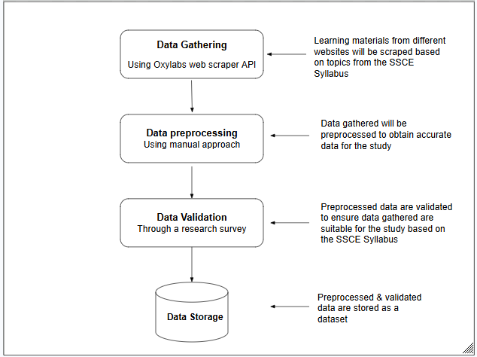

Fig.3.2: Sequence diagram for the data extraction
3.3.2. Knowledge Graph Creation Phase
The second major phase in the development of the SSM-LPRS, is the Knowledge Graph creation phase. This phase presents details of all the stages (modules) and procedures used in creating the desired knowledge graph for the study. Given that the proposed system is an educational software application, the resulting Knowledge Graph will be referred to as an Educational Knowledge Graph (EKG). The Knowledge Graph creation phase focuses on knowledge modelling, which will result in the development of a structured representation of domain concepts and their relationships.
The creation of the Educational Knowledge Graph consists of three (3) distinct stages (modules) in line with the studies by Chen et al. (2018), Dang et al. (2021), Gao et al. (2021), Liu et al. (2023), Shi et al. (2025), Siren and Tzerpos (2022). The stages will be implemented sequentially in a modular form. The output from one module feeds directly into the next, resulting in the creation of the intended Educational Knowledge Graph shown in Fig. 3.6.
These modules/stages are:
- Concept/Entity extraction stage,
- Relationship extraction stage; and
- Integration of graph database management system stage.

3.3.2.1 Concept (Entity) Extraction Module
The first major stage in the creation of the Educational Knowledge Graph, is the concept extraction stage. Concept extraction also known as entity extraction is the process of extracting key concepts (topics) from a dataset and classifying them into distinct classes based on certain pre-defined relationships (Chen et al., 2018; Siren & Tzerpos, 2022). Liu (2023) stated that entity extraction is the process through which knowledge nodes in a knowledge graph are identified and constructed.

Concept extraction involves two (2) distinct but interrelated subtasks, namely- keywords extraction, and data classification as seen in the study by Siren & Tzerpos (2022). Each, of these subtasks, contributes to the systematic identification and representation of a domain-specific knowledge. These subtasks are discussed as follow:

- Keywords Extraction: Keywords extraction is the process of identifying and extracting keywords from stored data. Keywords refer to very important words that reflect major topics or themes contained in a corpus or a dataset (Siren & Tzerpos, 2022). The data gathered in sub-section (3.2.1) are stored randomly as raw data. To effectively use them for this study, they need to be extracted and organized into meaningful Concepts (topics).

- Data Classification: In data classification, the extracted keywords are categorized or classified into major Classes or simply called Concepts. Each Concept is equivalent to a node in the Knowledge Graph. In this study, each Concept represents a major topic in the SSCE Mathematics syllabus.

To achieve these tasks (extraction and classification of data), the study adapted Chen et al. (2018) Concept extraction model. The model consists of three layers; the first layer is the Embedding layer; the second layer is the Classification layer, and the third layer is the Prediction layer. The specific functions of each of these layers and how they inter-relate to achieve the task of the concepts extraction is shown in the sequence diagram in Fig.3.4.

These layers are discussed one after the other as follows:

- Embedding Layer:

Word embedding is a technique in Natural Language Processing (NLP) use to convert textual data into numerical representations. This is important because computer models/systems cannot process textual data in their raw state, hence the need to first convert them to numerical formats. Thus, when the embedding layer receives the preprocessed data sub-section (3.3.1) as inputs, it converts the textual data into numerical representations using Word2vec algorithm.

The Word2vec algorithm performs word embedding by transforming textual data into dense vector representations through neural network-based learning. Each word is mapped to a vector and words with similar meaning are semantically positioned close to one another in a vector space. Supporting this view, Siren and Tzerpos (2022) observed that in addition to textual transformation, Word embedding enhances data classification and reveals sematic and syntactic relationships between words.

The output from the embedding layer is a dense vector representations stored in a low-dimensional vector space, expressed as: $x_{t}∈R^{dx}$ where $x_{t}$ is an input vector at a given time step $\left(t\right)$, R is a set of real numbers and dx represents the dimension assigned for each vector.

- The Classification Layer:
The Classification layer is responsible for extracting and classifying data into meaningful educational concepts. The study adopts the Gated Recurrent Units (GRU) classifier for the extraction and classification tasks. After the embedding layer converts words into dense vectors, the GRU extracts relevant textual features and hidden patterns needed for concepts identification and classification.

The GRU belongs to the Recurrent Neural Networks (RNN) class of deep learning models which are specifically designed for processing sequential data (Chen et al., 2018; Mienye et al., 2024). Liu et al. (2023) observed that, they are highly suitable models for educational data processing, hence it is adopted for this study.

To clearly understand how the GRU layer works, it is important to briefly describe the basic components of the of the GRU architecture, their functions and how the components interact to perform its function as seen from the studies by Bousnguar et al. (2023), Chen et al. (2018) and Mienye et al. (2024), among others.

- Components of the GRU Architecture

The GRU architecture, consists of two gates and three hidden states (see Fig.3.3). The two gates are the reset gate ${(r}_{t})$ and the update gate $\left(z_{t}\right)$ while the hidden states are the previous hidden state ${(h}_{t-1})$, the candidate hidden state ${(ȟ}_{t})$ and the final (new) hidden state $\left(h_{t}\right)$ as shown on the GRU architecture in Fig.3.3. The gates control the flow of information in the network by iteratively discarding less important portion of the information while retaining relevant portions from the previous hidden state ${(h}_{t-1})$. On the other hand, the hidden states $\left(h_{t-1, }ȟ_{t}, h_{t}\right)$ serves as the memory for the network, by retaining and passing the summary of the previous time steps to the next time step.

The specific function of each of the gates and the hidden states are as follow:

- The reset gate ${(r}_{t})$ determines which information from the previous hidden state ${(h}_{t-1})$ is less relevant (redundant) and hence be discarded.
- The update gate $\left(z_{t}\right)$ determines which information from the previous hidden state ${(h}_{t-1})$ is relevant to be retained.
- The previous hidden state ${(h}_{t-1})$ refers to the updated state of the network in the last time step $\left(t\right)$.
- The candidate hidden state ${(ȟ}_{t})$ is an intermediate value computed when a new input $\left(x_{t}\right)$ is combined with the previous hidden state $\left(h_{t-1}\right)$.
- The final hidden (new) state $\left(h_{t}\right)$ is the updated state of the network in the current time step $\left(t\right)$.
- The time spent to process each word vector is known as ‘time step’ $\left(t\right)$.

- Working Mechanism of the GRU Model

When the GRU layer receives the vectorized data from the embedding layer as input, it performs sequence modelling using its gating mechanisms. The GRU processes the input vectors sequentially, one word vector at a time, while maintaining a memory of previously processed words. During this process, the GRU keep updating its internal memory states (hidden states) at each time step $\left(t\right)$ by discarding the less relevant portion of the content while retaining important portion for update of the network. This dynamic gating mechanism is clearly illustrated by the GRU Architecture (see Fig. 3.3).

The functions and activities of each the gate and hidden state are explained as follows:

- The Reset gate: the reset gate ${(r}_{t})$ determines how much of the previous information to be discarded. It performs this task by combining the input $\left(x_{t}\right)$ and the previous hidden state ${(h}_{t-1})$ together and passes them through the sigmoid function (σ) resulting in the values between 0 and 1 as shown in Eq. (3.1). The value 0 implies that the previous state is less relevant and should be discarded. Likewise, the value 1 indicates that the previous state is relevant and to be retained.

- The Candidate Hidden State: The candidate hidden state ${(ȟ}_{t})$ computes and holds the intermediate (new memory) value of the current state of the network. This task is achieved when the previous hidden state ${(h}_{t-1})$ is multiplied by the output from the reset $\left(r_{t}\right)$ gate and in the process discarding less relevant portion of the information. Similarly, the relevant portion of the information is subsequently combined with the new input $\left(x_{t}\right)$ and passed through the tanh activation function to obtain the candidate state ${(ȟ}_{t})$ for that time step $\left(t\right)$ as shown in Eq. (3.2).

- The Update Gate: The update gate $\left(z_{t}\right)$ determines which information from the previous hidden state ${(h}_{t-1})$ is relevant to be retained and hence be updated. It performs this task in a similar manner like the reset gate by combining the new input $\left(x_{t}\right)$ with the previous hidden state ${(h}_{t-1})$ and subjecting them through the sigmoid function $\left(σ\right)$, it generates an output which is the updated or new hidden state $\left(h_{t}\right)$ as shown in Eq. (3.3).

- The Final Hidden State: The final hidden or new state $\left(h_{t}\right)$ is the updated state of the network in the current time step; it is also known as the working memory of the network. It is computed by calculating the weighted average between the previous hidden state ${(h}_{t-1})$​ and the candidate state ${(ȟ}_{t})$ , passed through the update gate ${(z}_{t})$ as shown in Eq. (3.4). It serves as the output of the current time step $\left(t\right).$

The output from the current time step $\left(h_{t}\right)$ is then passed to the next time step and this process is repeated across many time steps. At the last time step, the GRU produces $\left(h_{T}\right)$, which encodes information for the entire sequence. This gating mechanism enables the GRU to adaptively and dynamically maintain a balanced flow of information across the network, thereby capturing short- and long-term dependencies effectively.

This process is expressed mathematically as follow:
At each time step $\left(t\right)$;
- the GRU receives the:
- Current input vector $\left(x_{t}\right)$; and the
- Previous hidden state ${(h}_{t-1})$

- Then performs the forgetting and updating operations through the gating mechanism as shown in Equations (3.1 - 3.4) as follow:
- $Reset Gate: r_{t}= σ\left(w_{r}x_{t}+u_{r}h_{t-1}+b_{r}\right)………………………………….Eq.\left(3.1\right)$
- ${Candidate Hidden State:ȟ}_{t}=\tanh\left(w_{h}x_{t}+u_{h}\left(r_{t}ʘh_{t-1}\right)+b_{h}\right)………Eq.\left(3.2\right)$
- $Update Gate:z_{t}=σ\left(w_{z}x_{t}+u_{z}h_{t-1}+b_{z}\right)…………………………………Eq.\left(3.3\right)$
- $Final Hidden State:h_{t}=\left(1-z_{t}\right) ʘ h_{t-1}+z_{t}ʘ ȟ_{t}………………………Eq.\left(3.4\right)$

In the equations above,
- $w_{r}, w_{z} and w_{h}$ represents the weights for the reset, update and candidate gates. These weights known as input-to-hidden weight matrices or simply input weights acts on the current input vector ${(x}_{t})$ according to the function of each gate.
- $u_{r}, u_{z}and u_{h}$ also represents the weights of the reset, update and candidate gates respectively. However, these weights are known as the hidden-to-hidden weight matrices or simply the recurrent weights, acts on the previous hidden state ${(h}_{t-1})$ according to the function of each gate.
- $b_{r}, b_{z} and b_{h}$ are bias vectors.

- $Hadamard or Schur product \left(ʘ\right):$This function performs element-wise multiplication (that is, element-by-element multiplication) on two matrices of the same dimensions to produce a third similar matrix. In this model, the Hadamard product function, combines the two gate outputs with the hidden states as seen in eqns. (3.2) & (3.4), which helps to control the flow of memory dynamically across the network.

- $Sigmoid function \left(σ\right):$ This is a non-linear activation function that generates output of real numbers that are between the range of 0 and 1. Thus, the Sigmoid function acts like a gate, thereby controlling the flow of information through the network as seen in eqns. (3.1) & (3.3). Where:
- 0 implies gate close (restricting the flow of information); and
- 1implies gate open (allowing the flow of information).

- $Hyperbolic Tangent \left(Tanh\right):$ This is an activation function and is defined as the ratio of the hyperbolic sine to hyperbolic cosine. It is a function that maps input (real numbers) and produces output values that ranges from -1 and 1.

The final output from the GRU model, consists of streams of vectors known as logits generated for each class. These logits, are real numbers that can be infinitely negative to positive and do not sum to 1. Hence, are regarded as unnormalized probabilities and not suitable for predictions.
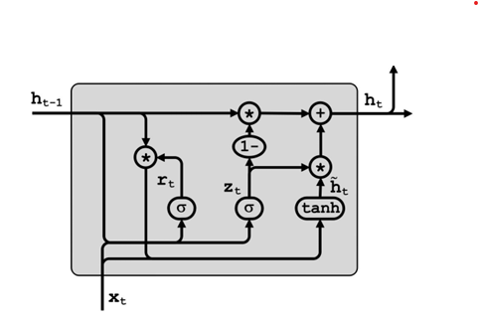

Fig.3.3: Architecture of a GRU cell (Chen et al., 2018)

- The prediction layer: This layer is responsible for normalizing the output from the classification layer using the Softmax activation function. The choice of Softmax for this study is because of its suitability in handling multi-class prediction tasks.

The Softmax function acts on the outputs (logits) from the GRU model, transforming them into a normalized probability distribution. To achieve this result, Softmax first converts all the outputs from the GRU into positive real-valued probabilities by calculating the exponential value of each output. It then normalizes these values by dividing each exponentiated value by the sum of all exponentiated values. This process produces a normalized probability distribution in which the probabilities range between $\left[0,1\right]$ and their total sum equals 1. The Mathematical expression of the Softmax function is shown in Eq. (3.5).
$σ\left(z_{i}\right)=\frac{e^{z_{i}}}{Σ_{j=1}^{k}e^{z_{j}}} ……………………………………. Eq.\left(3.5\right)$
Where:

- $z_{i}$ = the output of the $i^{th}$or current class
- $e^{z_{i}}$ = exponential value of the$i^{th}$or current output
- $K$ = total number of classes
- $\sum_{j=1}^{K}{e^{z_{j}}}$ = sum of exponentials of all output values
- $σ\left(z_{i}\right)$ = probability assigned to class $i$
Summary of Concept Extraction Stage

In summary, the concept extraction module consists of three layers- Embedding, Classification and the Prediction layers.
- Firstly, the embedding layer receives the preprocessed data from the data extraction stage as inputs and transforms the textual content into numerical formats known as word vectors using Word2vec algorithm.
- Secondly, the Classification layer processes the vectorized data recieved from the embedding layer and, through its gated sequential modelling mechanism, identifies, extracts, and classifies entities accordingly.
- Thirdly, the Prediction layer receives the unnormalized output from the Classification layer and transforms them into a normalized probability distribution suitable for predictions using the Softmax activation function.

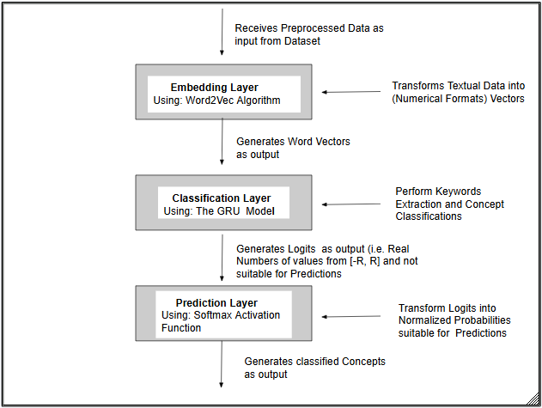

Fig.3.4: Sequence Diagram for the Concept Extraction Module

3.3.2.2 Relationships Extraction Module:

The second major stage/module in the creation of the Education Knowledge Graph, is the Relationship extraction stage. Relationship extraction is the process of identifying relations that interlinks or connects classified instructional concepts together to form a Concept map or Knowledge Graph, using relationship mapping techniques (Chen et al., 2018; Siren & Tzerpos, 2022). Shi et al. (2020) stated that Concepts are linked or connected together by edges based on certain semantic relationships resulting in the formation of Knowledge Graphs. In a Knowledge Graph, the nodes of the network represent the instructional Concepts while the edges represent the relationships between them (Wang et al.,2022).

To achieve the intended Concept map (Knowledge Graph), this study adopts a hybrid approach by combining the Prerequisite and Similarity relations to link the classified Concepts (see Section 3.3.2.2). this is in line with the approaches identified by Chen et al. (2018) and Siren and Tzerpos (2022). Specifically, prerequisite relations map the predecessor-successor dependencies between concepts, while similarity relations capture the semantic and logical aspects of their alignment. These procedures are illustrated in Fig. 3.6.
Details of how each of these relationships function are presented as follows:
a. Prerequisite Relations:
Prerequisite relations represent directed dependencies between concepts, where a target concept relies on one or more preceding concepts for proper understanding. This relationship establishes a hierarchical structure, ensuring that foundational concepts are mastered by learners before proceeding to study another. Manrique et al. (2019) remarked that Prerequisite relations exist between concepts as a natural dependency in cognitive or learning processes, influencing the way learners acquire, structure, and apply knowledge.

In the context of pedagogy, a prerequisite is a dependency relation that refers to the basic Concepts a learner is expected to have understood prior to engaging with a new Concept (Chen et al., 2018; Manrique et al., 2019; Siren & Tzerpos, 2022). By linking Concepts through prerequisite relations, a sequential chain of dependencies is formed, which ultimately result in the formation of a structured Concept map that reflect the logical organization of domain knowledge (Siren & Tzerpos, 2022) as shown in Fig.3.5.

Prerequisite Relations in this study will be established by combining data-driven Association Rule Mining (ARM) with a knowledge-based expert (manual) approach. The role of the expert is to ensure that the generated relations align with the hierarchical structure of the SSCE Mathematics Syllabus.

Association rule mining is an effective data mining technique for discovering relationships, patterns, associations or correlations among items in large databases (Chen et al., 2018; Ogedengbe et al., 2024; Prasad & Raman, 2017). It emphasizes concept relatedness and co-occurrence of items without regards order or sequence. In other words, association rule is use to find items that frequently appear together in a single transaction. Association rule has been used extensively in identifying several relations among entities in datasets including prerequisite relationships as seen the studies of Chen et al. (2018), Ma et al. (2023), among others.

Association rule mining, like other rule-based techniques, relies on IF–THEN conditional rules to establish frequent co-occurrence relationships among entities in a dataset. The “if” part of the statement refers to the antecedent while the “then” part refers to the consequent of the rule. The antecedent refers to the item identified in the database, while the consequent denotes the item that occurs in association with the antecedent (Parate et al., 2022).

The association rule is expressed in the form of $P→Q$. This means that whenever P occurs, Q will likely occur too.
Where:
- P and Q are items of an itemset in a transaction; and $P∩Q=∅$ .
- An itemset is defined as a collection of items (topics or concepts) that occur together within a transaction (e.g., a lesson, test, or learning session).

To conduct association rule mining, this study utilizes the Apriori algorithm. Apriori uses some basic evaluation metrics in determining the strength and reliability of item relationships in Association rule mining. Support and Confidence being the two most identified metrics in literature (Parate et al., 2022). These are briefly discussed as follows:

- Support: Support measures how frequently an itemset appears in a dataset (Parate et al., 2022). In other words, Support, measures the frequency of an itemset in all the transactions within a dataset. For instance, it can be used to measure how often the itemset - {Algebraic Expressions, Linear Equations} appears in all the transactions in a dataset. Thus, an association rule can be generated as:

{Algebraic Expressions} ⇒ {Linear Equations}.

This suggests that a student studying algebraic expression is most likely to study linear equations as well within the given session.

Support metrics can be expressed mathematically as the fraction/percentage of all the transactions containing an item or itemset in a dataset to the total number of transactions in the dataset. Thus, Support of an item P can be calculated as:

$Support\left(P\right)=\frac{Number of transactions containig P}{Total number of transactions}….……………..Eq.(3.6)$

Similarly, given X as the itemset for the items P and Q, the Support of X can be expressed as:
$Support\left(X\right)=\frac{Number of transactions containing X}{Total number of transactions}………………... Eq.(3.7)$
Which can also be written as:
$Support \left(P→Q\right)=\frac{Number of transactions containing P∪Q}{Total number of transactions}………..Eq.(3.8)$

- Confidence: Confidence is a statistical measure used to evaluate the strength of an association rule, reflecting the probability of the consequent occurring in transactions that contain the antecedent. In other words, Confidence measures the strength of the association rule by estimating how often the precedent (e.g. item Q) appears when the antecedent (e.g. P) appears in a dataset. It is expressed mathematical as:

$Confidece \left(P→Q\right)\frac{Support \left(P∪Q\right)}{Support \left(P\right)}…………………………………. Eq.(3.9)$
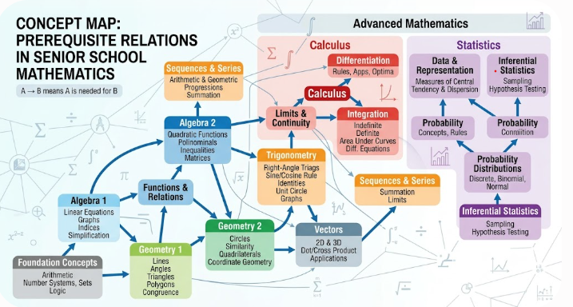

Fig.3.5: A Concept Map
b. Similarity (inclusion) Relations

The similarity or inclusion relationship measures the extent to which entities are alike within a corpus. It reflects the degree of resemblance between entities, or the extent to which they share common elements or characteristics (Siren & Tzerpos, 2022). Thus, a similarity algorithm, automatically links or connect a concept to another concept with the highest similarity score. Chen et al. (2018) observed that the hierarchical structure of a course or subject can be generated using the similarity relations.

This study, adopts the Cosine Similarity algorithm to calculate the similarity score.

The Cosine Similarity formula is used to measure the degree of similarity between two n-dimensional vectors based on the angle between them, without regards to their magnitude or the distance between them (Park et al., 2020). Wang et al. (2024) observed that Cosine similarity formula is an efficient method widely employed for capturing semantic relationships; thus, it was considered suitable for this study.

The Cosine Similarity (CosSim) score is calculated by dividing the dot product of the two vectors by the product of their magnitudes. This is expressed as:

$CosSim \left(A,B\right)=\frac{A.B}{\left\|A\right\| \left\|B\right\|}………………………………………………Eq.(10)$
​
Where:
$A∙B$ is known as the dot product of vectors A and B and can be derived as follow:
$A∙B=Σa_{i}b_{i}………………………………………………………………Eq. (3.11)$

Also, ∣∣A∣∣ and ∣∣B∣∣ are the magnitudes of vectors A and B, which can also be derived from the follow:
Magnitude of A: $\left\|A\right\|=\sqrt{Σa_{i}^{2}}…………………………………………….. Eq. (3.12)$

Magnitude of B: $\left\|B\right\|=\sqrt{Σb_{i}^{2}}……………………………………………..Eq.(3.13)$

The values of the cosine similarity score ranges from -1 to 1. The score value 1 indicates a perfect or maximum similarity, this means that the two vectors, points in the same direction and the angle between the vectors is zero degree (0⁰). Also, the score value 0 indicates orthogonality, which means that the vectors are perpendicular (90⁰) to one another, hence there is dissimilarity in the direction of the two vectors. Finally, the score value -1 indicates that the vectors are in opposite direction, meaning they are at 180⁰, hence there is no similarity at all between the vectors. In a nut shell, the closer the score value is to 1, the smaller the angle between the two vectors, implying more similarity.

Summary of Relationship extraction module

Conclusively, the relationship extraction stage establishes the functional structure of the educational knowledge graph to be used for the development of the SSM-LPRS software by clearly establishing prerequisite and similarity relationships among concepts resulting in the formation of the knowledge graph.

Thus, on one hand the prerequisite relationship serves to establish the links between concepts based on the predecessor and successor dependencies among concepts; showing clearly the sequential connections between concepts, resulting in the formation of a concept map. Siren & Tzerpos (2022) observed that the process of determining the Predecessor and successor dependencies between concepts (e.g. learning objects) is essential in creating knowledge graphs and recommender systems.

On the other hand, the similarity or inclusion relationship provides structured, logical and semantic links between concepts based on what one concept has in common with another concept or how much concepts are contained in one another (inclusion), consequently resulting in the hierarchical structure of the graph (Chen et al., 2018) that comprehensively captures all core topics specified in the SSCE Mathematics syllabus.
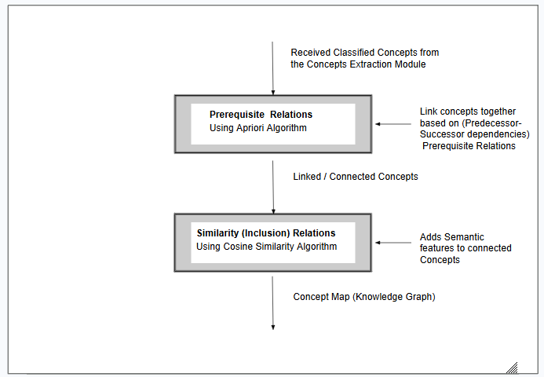
Fig.3.6: Workflow Diagram for the Relationship Extraction Module
3.3.2.3. Integration of Graph Database Management System:

The final stage of the knowledge graph creation process, is the integration of a graph database for the storage and management of the educational knowledge graph created for the SSM-LPRS. A graph database stores information using its nodes for entities and its edges for relationships in the form of triples (subject, predicate, object) based on the Resource Description Framework (RDF) model (Dang, et al.,2021; Liu et al., 2023 & Shi et al., 2025). Where the subject (s) and the object (o) in the structure represent entities while the predicate (p) represent the relationship between them. In addition to its structure, graph databases are enhanced with semantic, ontological, visualization and query properties, which makes graph databases particularly well-suited for storage and efficient management of knowledge graph systems (Dang, et al.,2021; & Shi et al., 2025). In this study, the Neo4j graph database management system will be adopted for the storage and management of the educational knowledge graph developed for this study.

Summary of the Knowledge Graph creation

In summary, the Educational Knowledge Graph (EKG) for this study will be developed based on the three main stages identified and discussed in section (3.3.2). The first stage of the EKG creation is the concept extraction stage. In this stage, instructional concepts will be extracted from the preprocessed dataset and classified using an adapted concept extraction model described in sub-section (3.3.2.1).

The second stage of the EKG creation is the relationship extraction stage. In this stage, relationships (prerequisites and similarities) between extracted concepts will be established. The Apriori algorithm will be employed to extract prerequisite relationships between concepts, whereas cosine similarity will be used to determine the extent of semantic similarity between the concepts (see sub-section 3.3.2.2), Consequently, the intended educational knowledge graph for the study is realized.

Finally, the third stage is the integration of a graph database, for the storage and management of the created EKG, using neo4j graph database management system in line with the study by Liu et al. (2023), Shi et al. (2025). The details of these stages and how they relate to create the Knowledge Graph is presented in Fig. 3.6

Consequently, a robust educational knowledge graph is created, with the domain knowledge and logical flow of learning objects from simple to advanced topics clearly established and represented in accordance with the hierarchical structure of the SSCE mathematics syllabus. Detailed procedure for the development of the EKG is illustrated in Fig.3.6.
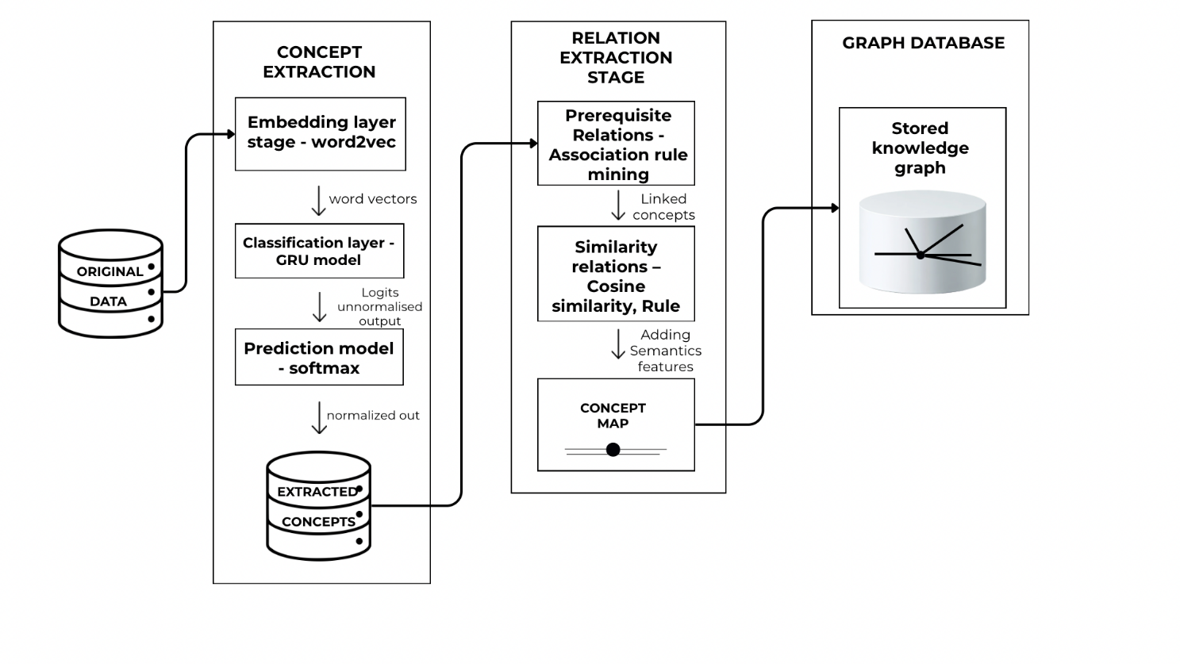
Fig.3. 7: Schematic diagram of the Knowledge Graph creation Module

3.3.3. Learning Path Creation and Recommendations Phase:

The third major phase in the development of the SSM-LPRS is the Learning Path creation and Recommendations phase. This phase focuses on syllabus-level sequencing of learning resources to learners using the created Educational Knowledge Graph. Rahayu et al (2023), observed that learning paths has been used in studies either as course sequencing within a given program or as learning objects sequencing within a particular course. Due to the large scope and the complex nature of this study, the intended learning path to be generated will encompass the two types of sequencing identified above. This is because the syllabus consists of several topics and sub-topics which are taught and learnt progressively in three successive sessions (SS¹-SS³) until all the topics in the syllabus are fully covered.

Thus, the learning path required by a learner to master a specific topic will be realized through learning objects sequencing within a course, whereas the learning path required for a learner to progressively cover all topics in the SSCE Mathematics syllabus (SS¹-SS³) will be realised through course sequencing within a program. Where course is used to represent a complete topic (e.g. Algebra) while a program refers to the entire SSCE educational program.

Specifically, this phase deals with how to generate feasible learning pathways and recommends personalized learning resources to learners based on the paths created. It consists of two interrelated stages which are: the Learning Paths creation stage and the Recommendation stage, in line with the studies by Gao et al. (2021), Ma et al. (2023) and Shi et al. (2020).

To achieve these tasks, the study adopts a hybrid approach combining two algorithms: Dijkstra algorithm shown in Eq. (3.14) and the Ant Colony Optimization (ACO) algorithm presented in Eq. (3.15) – Eq. (3.19). The Dijkstra algorithm generates the optimum (shortest) learning paths while the ACO generates personalized learning paths for learners. The workflow diagram is of this process is illustrated in Fig.3.7.

The details of the Learning Paths creation stage and Learning Paths Recommendation stage are discussed as follows:

3.3.3.1 Learning Path Creation Stage:

One of the primary objectives of this study, is to create feasible learning routes (pathways) for learners by automatically generating logical sequences of cohesive learning objects. Learning path generation is the process of creating structured sequences of learning concepts or learning objects based on domain-specific knowledge, which enable learners to systematically navigate and study desired concepts/topics or a course (Gao et al., 2021).

Learning objects serves dual purposes for learners; first, as instructional resources and secondly as learning pathways. Through the sequential ordering of learning objects, pathways are automatically created that guide learners progressively toward achieving specific learning goals within a defined timeframe. In the context of this study, the learning pathways will traverse progressively across the entire syllabus, ultimately covering all the major topics in it.

The generation of learning path in this study consists of two main tasks. The first task is to identify the possible relationship constraints; which helps to determines the extent to which learning pathways can be generated (Shi et al., 2020). The second task is to apply the Dijkstra algorithm given in Eq. (3.14), to generate all the feasible learning pathways within the defined constraints. These are discussed as follows.

- Constraints:
Constraints refer to limitations, restrictions, or boundaries that govern a process. The study identifies two primary sources of constraints. The first stems from the structure and content of the syllabus. The hierarchical organization of the syllabus imposes inherent limitations, such as topics to be covered, the levels of study, programme duration, and prerequisites among concepts. The second source of constraints arises from the learning characteristics of the learners. These include individual learning styles, cognitive abilities, and other learner-specific needs. Invariably, these and other pedagogical constraints will influence how the learning paths to be created and recommended.

- Learning Path Generation using Dijkstra Algorithm

This study employs Dijkstra algorithm to generate optimum learning paths for learners from the Knowledge Graph created in section (3.3.2) subject to the identified constraints.

Dijkstra is a deterministic graph-based algorithm, also known as a greedy graph search algorithm. It is used to find the absolute shortest path between a starting node and all other nodes or to a specific destination in a weighted graph. It works by iteratively selecting the node with the smallest known distance from the source and updating the distances of its neighbouring nodes until all nodes have been visited (Parmanand et al., 2024). This algorithm has been used successfully in generating optimum learning paths for learners as seen in the systematic survey study by Shi et al. (2020).

The steps below illustrate how the Dijkstra’s Algorithm Works:
- Assign a distance value of 0 to the starting node and ∞ (infinity) to all other nodes;
- Mark all nodes as unvisited;
- Select the unvisited node with the smallest distance (the initial or start node);
- Update the distances of its neighbouring nodes based on edge weights;
- Mark the current node as visited;
- Repeat the process until all nodes are visited or the target node is reached.

The Dijkstra algorithm will be applied to generate optimum learning paths for learners using the distance update formula. Given a weighted Knowledge Graph (G), expressed as G (V, E, W).
Where:
- V = nodes: represents learning concepts;
- E = edges: represents prerequisite relations;
- W= weights: represents constraints (difficulty, time, cognitive load).

The optimal learning part can be generated from the distance update formula:

$P\left(s,t\right)=\arg{\min{Σw(u,v)}}…………………………………………………Eq. (3.14)$

Where:
- s = Source node (learner’s current knowledge state);
- t = Target node (learning goal);
- w (u, v) = edge weights (learning costs/constraints inherent in moving from s to t);
- P = The shortest path from source s to target t

This process is repeated iteratively until all the nodes (i.e. topics) are successfully explored or a desired destination (learning goal) is reached. Ultimately, this is how the system generates all the desired learning paths.

3.3.3.2 Learning Path Recommendation Stage

The second stage of the Learning Path creation and Recommendations phase, is the learning paths recommendations stage. Learning Path Recommendation is the process of selecting and recommending the most appropriate learning paths for individual learners based on their learning preferences, learning styles, cognitive level, among others (Shi et al., 2020). The study employs the Ant Colony Optimization (ACO) algorithm to generate personalized recommendations of learning resources to leaners based on the learning paths created by the Dijkstra algorithm (see Eq. 3.14).

Ant Colony Optimization (ACO) algorithm belongs to the category of swarm intelligence algorithms that employs probabilistic techniques to solve a wide range of combinatorial optimization problems by identifying the shortest and most cost-effective paths (Lingkon & Ahmmed, 2024). Rezvanian et al. (2023) and Zhang et al. (2026) defined the

Ant colony optimization as a metaheuristic algorithm that is inspired by mimicking the foraging behaviour of actual ant colonies in their intuitive search for food by using pheromone (depositions) trails and heuristic information to establish the shortest (optimal) paths.

Typically, ants initially explore their environment randomly in search of food. Once a food source is found, they return to the nest while depositing pheromones along the discovered path. The intensity of the pheromone trail reflects the quality and quantity of the food source which gradually evaporates over time. The residual pheromone on a path influences other ants to follow it. Consequently, within a short period, most ants tend to converge on the shortest path, reinforced by the strongest pheromone trail (Rezvanian et al., 2023; Zhang et al., 2026).

Several studies affirmed the effectiveness of using ACO to find optimal path in graph-based problems (Zhang et al., 2026) and suitable in generating optimum learning paths in knowledge graphs (Gao et al.,2021). To gain a clear understanding of how the ACO algorithm operates, it is important to first grasp the meaning of key components underlying the algorithm and how it works. These are discussed below:

1. Key Components and parameters of ACO Algorithm: Some of the basic concepts commonly used in ACO include the following:
- Ants: These refers to simple agents (learners) that explore the problem space and construct solutions (learning paths) step by step.
- Pheromone trails: These are numerical values stored on edges of a graph that simulate actual pheromone left by real ants while traversing their food paths. They serve as memory the that store past experience and indicate which paths are more promising.
- Heuristic Information: Problem specific knowledge such as distance, cost or time that helps ants make informed decisions.
- Transition Probability: Ants choose paths using probabilities influenced by pheromones and heuristic values, rather than fixed rules.
- Pheromone evaporation: Pheromone levels gradually decrease over time, preventing premature convergence and encouraging continued exploration.

2. How the ACO algorithm works in generating optimal (learning paths) solutions
Similar to the behaviour of the actual ant colony, the ACO algorithm generates many solutions (learning paths) randomly when the algorithm is initiated. These learning paths are then iteratively improved as each ant traverse the graph (the problem space) repeatedly. Two key strategies used in obtaining the shortest path (optimal learning path) are the probabilistic path selection and dynamic pheromone updating (Zhang et al., 2026).
A brief summary of the basic steps involved in creating the shortest path using the ACO algorithms is hereby presented as follows:

- Initialization of pheromone: The first step is to assign small pheromone values to all likely paths. Initializing pheromone values:
$tij=t0…………………………………………..…………...…. Eq.(15)$
Where:
- $i$ is the start (source) node,
- $j$ is the next unvisited node,
- $t0$ is starting time.

- Paths Selection (Learning Paths construction): Each ant (a learner) builds a solution (learning path) incrementally by moving through the problem paths based on pheromones and heuristic information. In graph-based representations, pheromones are deposited on either the vertices or edges of the graph. At every point of the learning path formation, ant k at node $i$, may choose to migrate to a subsequent unvisited node $j$. This movement is based on the quality and quantity of deposited pheromones and the heuristic information available (Zhanget al., 2026). In other words, the probability with which the transition occurs is dependent on the both the level of deposited pheromones and the quality of the heuristic information. Invariably, paths with higher pheromone and better heuristic values are more likely to be selected.

The probability that this movement will occur is determined by the transition probability equation shown in Eq. (3.16).

$P_{ij}^{k}=\frac{{\left(τ_{ij}\right)}^{α}{\left(η_{ij}\right)}^{β}}{Σ_{j∈} N_{i}^{k}{\left(τ_{ij}\right)}^{α}{\left(η_{ij}\right)}^{β}}, if_{ j}∈N_{i}^{k},otherwise 0…………………..…Eq. \left(3.16\right)$

That is, $if_{ j}∉ N_{i}^{k}$ = 0

Where:
- $P_{ij}^{k}$: Represent the transition probability of ant k from node $i to j$,
- $τ_{ij}$: Represent the value of the pheromone trail,
- $η_{ij}$: Represent the heuristic information,
- $N_{i}^{k}$: Represent the set of nodes (learning objects) that can be visited by ant k.
- $α$: Controls the influence of pheromone trails on the path-selection process
- $β$: Controls the influence of heuristic information

It is important to also state that the heuristic information is a reciprocal of the distance between nodes two adjacent or neighbouring nodes. This implies that:
$η_{ij}=$ $\frac{1}{d_{ij}}………………………………………..…………………. Eq.(3.17)$
Where $d_{ij}$ is the distance between nodes $i and j$ respectively.

- Solution evaluation: The quality of each solution (each generated path) is evaluated using a fitness function. This function is used to measure how a particular solution solves a given problem effectively. In the context of this study, the evaluation is done to ensure the paths generated are pedagogically correct and meet the desired output.

Fitness function can be used to estimate maximation or minimization problems. If it a maximization problem, higher fitness value implies better solution while for minimization problems, lower fitness low implies better solution.

Fitness functions for minimization and maximization problems can be derived as follow:
For Minimization problems (e.g. difficulty in learning): F (path) = 1/total difficulties
For maximization problems such as profits (solutions): F (path) = Total profit

- Pheromone update: Pheromone trails update is carried out at the end of an iteration cycle when all viable paths have been created. The aim of the update is to improve the quality of solutions. Pheromone update consists of two stages, these are pheromone evaporation and pheromone deposition (Zhang et al.,2026).
- Pheromone evaporation: Natural dissipation is simulated with a constant decay factor that avoids premature convergence to suboptimal solutions.
- Pheromone Deposition: Ants deposit pheromone on the paths they traverse and the amount of the deposited is proportional to the quality of their constructed path.
In a nut shell, good solutions (paths) receive more pheromone reinforcement (deposition) while poor paths gradually disappear due to evaporation.

The pheromone update rule is expressed as:
$τ_{ij}\left(t+1\right)=\left(1-ρ\right)τ_{ij}\left(t\right)+\sum_{k=1}^{m}{Δτ_{ij}^{k}}…………………………….Eq. \left(3.18\right)$
Where:
$ρϵ\left(0,1\right)$ or simply $ρ(0<ρ<1)$, represents the coefficient of evaporation of the pheromone,
$Δτ_{ij}^{k}$ represent the amount of pheromone trail deposited on the edge between nodes $i and j$ by ant k within interval t.
The description of the tour is shown as following:
$Δτ_{ij}^{k}=\left\{\begin{aligned}\frac{Q}{L_{k}} , \\ 0, else\end{aligned}\right.$if ant k moved from node $i to j$ during the iteration ……………... Eq. (3.19
Where:
$Q$ is a constant value that represents the quantity of pheromones emitted by one ant in each iteration,
$L_{k}$ is the overall length of the trail created by the ant k. The paths with shorter lengths produce higher pheromone which reinforce better quality paths over time.

- Iteration until best path is found: The process iterates until a stopping condition such as an optimal path is identified or a learning goal has been met.

Summary of the Learning Paths Creation and Recommendations Phase

Leveraging on the Knowledge Graph created in sub-section (3.3.2) the study combined the Dijkstra algorithm with the Ant Colony Optimization algorithm to achieve the Learning Paths creation and Recommendations of personalized learning resources to learners.

Specifically, when a learner makes a request, the Dijkstra algorithm scans the Knowledge Graph and maps out the shortest (optimal) Learning Path mathematically using Eq. (3.14) strictly in accordance with established prerequisites relations. Thereafter, the ACO algorithm fine-tunes the outcome of the paths generated by the Dijkstra’s algorithm, by applying probabilistic and heuristic techniques using Eqs. (3.16) and (3.18). Consequently, it optimizes the process dynamically, resulting in personalized and adaptive paths. This process is illustrated in Fig. 3.7.
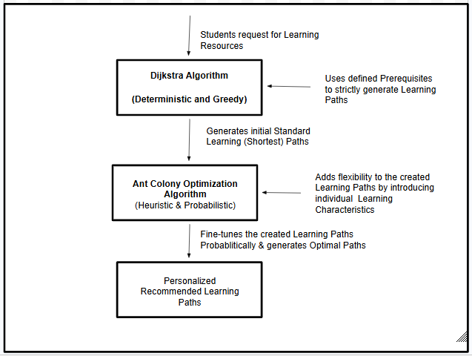

Fig.3.7: Workflow diagram of the combined Dijkstra and ACO algorithms

3.3.4 User Interface (GUI) Phase

The fourth phase in the development of the SSM-LPRS, is the Graphical User Interface phase. For the SSM-LPRS to effectively recommend personalized content to users, individual learners need to interact with system. The main focus of this phase is to develop graphical user interfaces that will allow learners and other users to effectively communicate with the system. The phase will include:
- Login/authentication phase;
- Learners’ profile phase;
- Mode of study phase.
This phase will be built using Python and the Flask micro-framework.

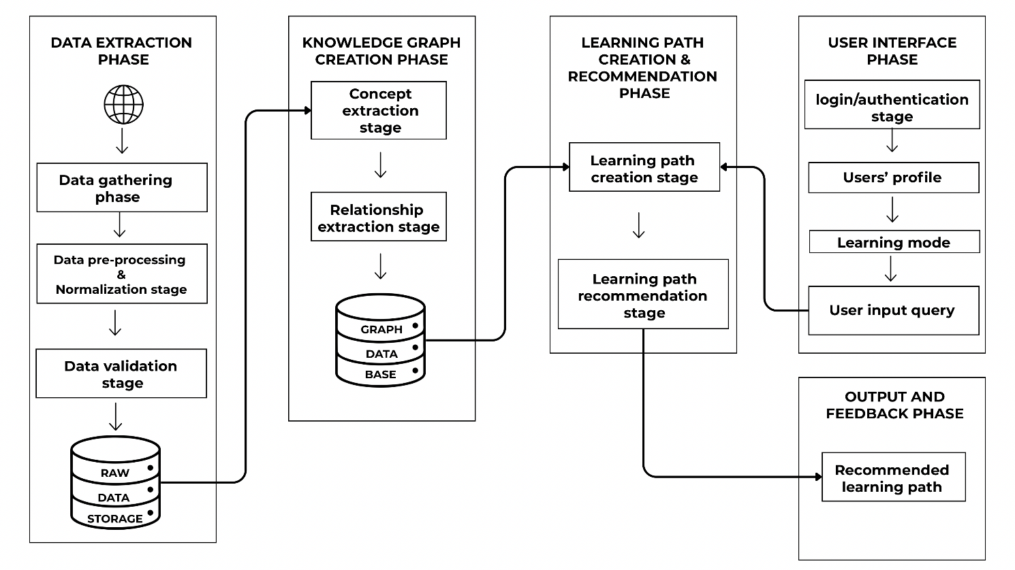
Fig.3.8: Schematic diagram of the complete System Architecture

3.4 Unified Modeling Language
The Unified Modeling Language (UML) provides a standardized approach to visually represent the design and operation of the proposed SSM-LPRS. UML diagrams serve as blueprints that describe the system’s structure, behavior, and interactions between different components, thereby facilitating a clearer understanding of how the system functions. The UML representation of the proposed system ensures that the conceptual design is clearly communicated and logically structured. By using UML, both technical and non-technical stakeholders can easily interpret the system requirements and workflows. These diagrams not only assist developers in implementation but also provide educators and stakeholders with an intuitive view of how the system delivers personalized learning paths to students.

The proposed system incorporates three basic UML diagrams to model its functionality. These are listed and discussed as follows:
- The system process diagram
- The use-case diagram
- The activity diagram

3.4.1 System process Diagram
The system process diagram outlines the sequential flow of activities within the system. It provides a holistic overview of how data moves through the system from input to output as illustrated in the system flow chart in Fig. (3.9).

The system process diagram for the study (see Fig. 3.9) illustrates the workflow of the Senior School Mathematics Learning Path Recommender System (SSM-LPRS) from user authentication to the delivery of personalized recommendations. Beginning with the authentication phase, users sign up for a new account or log in with existing credentials. At this stage, the system verifies user identity through authentication and authorization mechanisms to ensure secure access. Once authentication is successful, the user gains access to the learning environment. After authentication, the user is prompted to choose a preferred learning mode.

The system provides two distinct pathways. The first is the linear path, where the learner progresses through the curriculum in a sequential manner, starting from foundational topics and advancing gradually to more complex ones. This mode is ideal for new users who want to build knowledge step by step. The second is the targeted path, where the learner specifies a particular topic of interest. The system then checks the student’s academic level (SS1, SS2, or SS3) and learning history to determine whether expected prerequisite topics required to study the new requested topic have previously been covered successfully. If yes, the system generates and recommends learning objects suitable for the requested topic otherwise, the system recommends revisiting them before advancing.

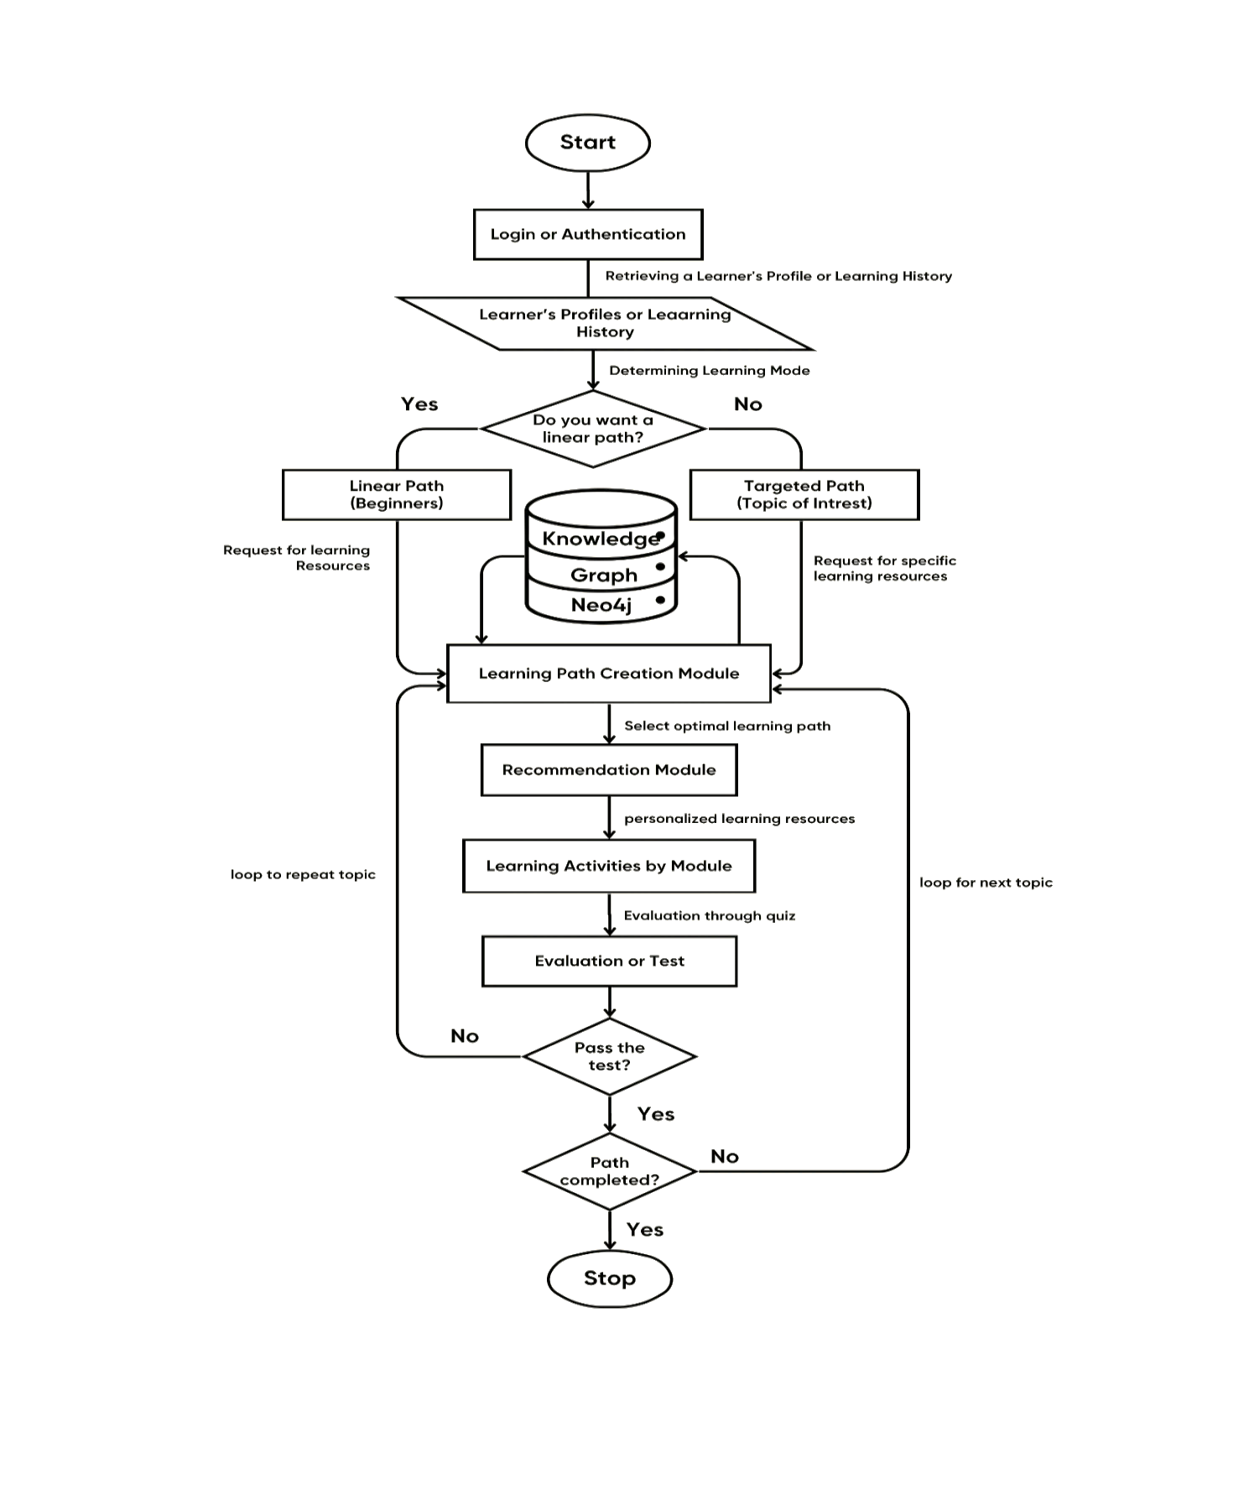
Fig. 3.9: System Flow chart
3.4.2 Use-case Diagram
The use-case diagram highlights the various actors and their interactions with the system. The use-case diagram in this study (see Fig. 3.10) illustrates the functional requirements of the SSM-LPRS System by representing the different interactions between users (actors) and the system. It highlights the services provided by the system and the various roles involved. The main actor in the system is the student, who interacts with the application to access personalized mathematics learning resources. A secondary actor is the administrator, who manages the database by adding, updating, or removing learning materials. When a student accesses the system, the first use case is sign up or login, which enables secure authentication. After successful login, the student can select a preferred learning mode. The system provides two options. Linear Learning Mode, where the learner progresses through topics sequentially from beginner to advanced levels. Targeted Learning Mode, where the learner specifies a topic of interest, and the system checks prerequisite topics and class level before providing access.

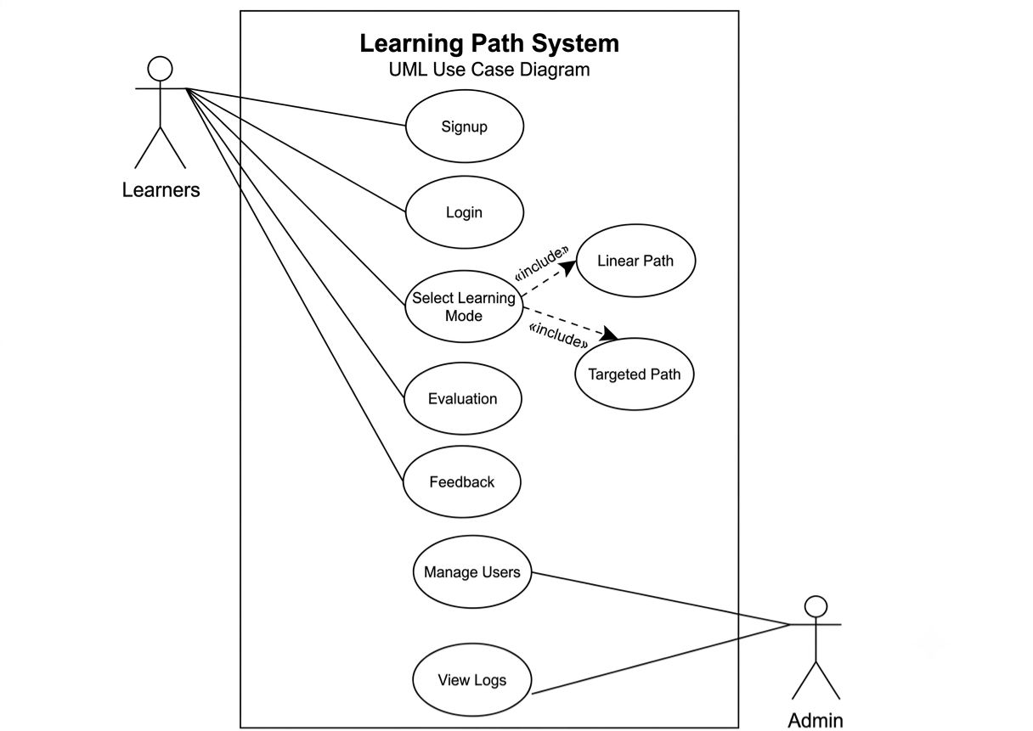

Fig. 3.10 Use-case Diagram
3.4.3 Activity Diagram
The activity diagram provides a step-by-step visualization of a learner’s journey through the system. It models the dynamic behavior of the application by representing decision points, such as whether the student selects a linear or targeted learning path, and the subsequent actions taken based on those choices. The diagram also illustrates the feedback loop where assessments determine whether the learner can progress to the next topic or repeats a topic. The activity diagram for this study is illustrated in Fig. 3.11

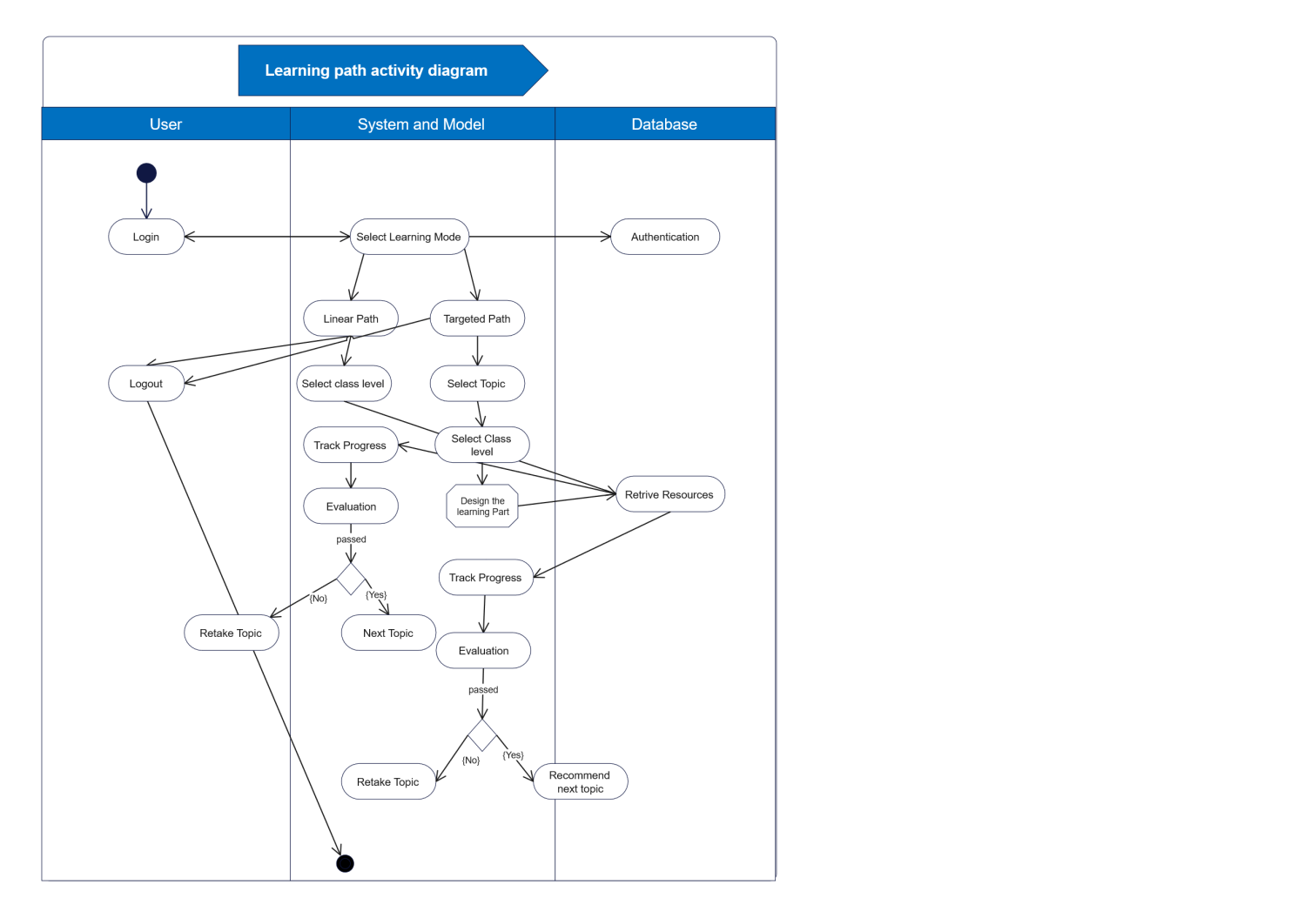
Fig. 3.11: Activity Diagram

3.5 Model Description
The SSM-LPRS is a multi-algorithmic design that incorporates several techniques to solve different tasks at different stages of the system development. The aim of the study is to develop a Learning Path Recommender System that will recommend appropriate learning resources to learners in accordance with the scope and content of the WASSCE Mathematics Syllabus using knowledge graph approach. The system consists of four distinct main phases as presented in section 3.3.2. These four phase are:
- The Data Extraction phase;
- Thel Knowledge Graph creation phase;
- The Learning Paths Creation and Recommendations phase;
- User interface phase.
The details of how each of these phases will be realized as well as their specific functions in the overall design of the SSM-LPRS are presented in sub-sections 3.3.1, 3.3.2, 3.3.3 and 3.3.4 respectively.
3.6 Functional Design
A top-down modular design approach will be adopted in the development of the proposed SSM-LPRS and will comprise of three main layers:
- Knowledge Presentation Layer;
- Recommendation layer.
- User Interface layer

The Knowledge presentation layer handles data extraction, concepts extraction and relationships extraction, leading to the formation of the educational knowledge graph. Data extraction will be carried out by using a web crawler (Oxylab API) to scrap relevant data from OERs and online websites as discussed in sub-section (3.3.1). Extracted data will be pre-processed, validated and stored as a dataset in a data base. The Concept extraction model will be is used to extract and classify key concepts from the pre-processed data. The Association rule mining and Cosine similarity algorithms will be used to identifies and establish relationships among these concepts. Consequently, the classified concepts are linked by relationships and structured into a knowledge graph and stored in a graph database (Neo4j). With nodes representing learning concepts and edges capture relationships such as prerequisite dependencies and conceptual similarities.

The Recommendation layer deals with the processes of generating and recommending learning resources to users. The Dijkstra algorithm is applied to compute feasible and optimum learning paths within the knowledge graph, while the Ant Colony Optimization (ACO) algorithm enhances personalization by recommending paths based on learners’ preferences, and performance data.
The users’ interactive layer is responsible for creating the graphic user interfaces that enables users to interact and use the system efficiently. It handles components such as the authentication module, learning mode selection, learning paths generation, recommendation of learning resources, and progress tracking module.

These layers interact seamlessly to ensure efficient data flow, from concept extraction to personalized recommendation delivery and will be implemented using Python codes. The modular design ensures scalability, maintainability, and smooth communication between all the functional modules of the system.

  - System Implementation
The system implementation phase involves translating the proposed SSM-LPRS model into a functional system by converting the technical design of all the modules into reality by using software tools listed in table (3.1). This phase operationalizes the design components by integrating the knowledge graph, learning path generation algorithms, recommendation mechanisms and the GUI into a cohesive functional system.

The system will be implemented using Python as the primary programming language, leveraging on its versatility and extensive libraries which supports machine learning, graph processing, and optimization algorithms. Specifically, the PyTorch framework to be used for GRU-based concept extraction, MLxtend for association rule mining and NetworkX for graph processing and Flask for web-based user interfaces (see table 3.1).

Specifically, the backend and frontend of the system will both be developed using Flask (Python), which serves as a lightweight and flexible web framework capable of handling both the model logic and user interface. The system’s web interface will be built using HTML, CSS, and JavaScript, integrated within the Flask environment to enable user’s interaction and smooth navigation. Flask routes handle user requests, communicate with the machine learning model, and retrieve or store data in the MySQL database hosted on XAMPP. In addition, the knowledge graph will be managed using Neo4j with Cypher query language.

The system will be hosted locally on a XAMPP server, which also provides an integrated environment for running Apache and MySQL. XAMPP was chosen for its simplicity, open-source nature, and suitability for local testing and development before online deployment.

  - System Integration and Evaluation

System integration is the process of combining individual system phases (modules) into a unified functional system and ensuring the components interact correctly and efficiently. The system integration phase of this study, focuses on ensuring seamless communication between the knowledge graph module, learning paths creation and recommendation module, the users’ interactive module, the web interface, and the MySQL database so as to achieve a fully functional Learning Path Recommender System, the SSM-LPRS. The integration is achieved through a modular architecture in which each component performs a specific function while maintaining interoperability with other components.

On the other hand, the System will be evaluated to assess the performance, accuracy, and effectiveness of the implemented Learning Path recommender system in line with its intended objectives. The system will be evaluated at two different stages by the following evaluation methods:
- Black Box evaluation method;
- Usability evaluation method.
At the initial stage of the system testing, the black box evaluation method will be used to evaluate the functional correctness of the system. This is done by comparing the outputs from the Learning Path Recommender System with the inputs to ascertain if the generated outputs correspond to the expected outcome (Liu et al., 2023). This evaluation will be carried out by experts. Thereafter, a usability evaluation will be conducted. This evaluation will focus on users’ experience, satisfaction and efficiency of the system. This will be carryout using learners and teachers.

In summary, system integration ensures that all components of the proposed system function cohesively, while system evaluation verifies the effectiveness, accuracy, and usability of the system. Together, these processes guarantee that the Learning Path Recommender System is reliable, efficient, and capable of delivering personalized learning experiences.

  - Deployment of the System
The system deployment phase involves installing, configuring, and releasing the developed system into a live environment for use by end users. At this stage, the fully developed and tested Learning Path Recommender System (SSM-LPRS) is made operational and accessible to users. To ensure wide accessibility and ease of use, the system is deployed as a web-based application, enabling users to access it seamlessly across various devices and locations.

The system would be hosted locally on an Apache server which provides the necessary computational resources and scalability required for handling user requests. The backend of the system, which includes the knowledge graph, learning path generation module, and recommendation engine, is deployed on the server, while the frontend interface is accessible through a web browser. The graph database (Neo4j) is configured on the server to store and manage the knowledge graph efficiently. Application programming interfaces (APIs) are implemented to enable communication between the frontend interface and backend components.

3.10 Maintenance of the system
System maintenance is a post-deployment phase of the system development life cycle, which focuses on ensuring the continuous functionality, performance, and reliability of the deployed system. In this study, maintenance activities are essential to sustain the effectiveness of the learning paths recommender system (SSM-LPRS) and to accommodate evolving user needs and curriculum changes.

Routine maintenance activities include checking for database inconsistencies, updating educational resources, retraining the GRU model with new learning data, and optimizing the local server configuration to improve responsiveness and stability. In addition, periodic evaluation of user feedback is conducted to identify and address usability or functionality issues that may arise during system usage. Error logs generated by the local server are regularly analysed to detect potential system failures, connectivity problems, or model performance issues. Maintenance also involves applying security patches, updating XAMPP components (Apache and MySQL), and ensuring compatibility with updated Flask and frontend frameworks.

References
Abu-Salih, B., & Alotaibi, S. (2024). A systematic literature review of knowledge graph construction
and application in education. Heliyon, 10. https://doi.org/10.1016/j.heliyon.2024.e25383

Alhawiti, M.M. & Abdelhamid, Y. (2017). A Personalized e-Learning Framework. Journal of
Education and e-Learning Research, 4(1), 15-21. Doi: 10.20448/journal.509.2017.41.15.21

Adnan, N.H. & Ritzhaupt, A.D. (2017). Software Engineering Design principles applied to Instructional Design: What can we Learn from our Sister Discipline? Tech Trends Springer. https://doi.org/10.1007/s11528-017-0238-5

Bouihi, B., & Bahaj, M. (2019). Ontology and Rule-Based Recommender System for e-Learning applications. International Journal of Emerging Technologies in Learning, 14(15). https://doi.org/10.3991/ijet.v14i15.10566

Bousnguar, H., Battou, A., & Najdi, L. (2023). Gated Recurrent units (GRU) for Time Series forecasting in higher education. International Journal of Engineering Research & Technology (IJERT), 12(3), 152-154. DOI: 10.17577/IJERTV12IS030091

Brik, M., & Touahria, M. (2020). Contextual Information Retrieval within Recommender System: Case Study “E-learning System”. Technology, Education, Management, Informatics (TEM) Journal, 9(3), 1150-1162. DOI: 10.18421/TEM93-41.

Chen, P., Lu, Y., Zheng, V.W., Chen, X., & Yang, B. (2018). KnowEdu: A System to Construct Knowledge Graph for Education. IEEE Access Journal, 6, 31553-31563. DOI: 10.1109/ACCESS.2018.2839607

Da Silva, F.L., Slodkowski, B.K., Da Silva, K.K.A., & Cazella, S.C. (2022). A systematic literature review on educational recommender systems for teaching and learning: research trends, limitations and opportunities. Education and Information Technologies https://doi.org/10.1007/s10639-022-11341-9

Dang, F., Tang, J., Pang, K., Wang, T., Li, S., & Li. X. (2021). Constructing an educational knowledge graph with concepts linked to Wikipedia. Journal of Computer Science and Technology, 36(5) 1200 – 1211. https://doi.org/10.1007/s11390-020-0328-2
Dang, V. T. (2020). Information confusion and intention to stop using social networking site: a moderated mediation study of psychological distress and perceived novelty. Journal of Information Technology and People, 33(5). DOI: 10.1108/ITP-03-2020-0117

Deschênes, M. (2020). Recommender systems to support learners’ agency in a Learning context: a systematic review. International Journal of Educational Technology in Higher Education, 17. https://doi.org/10.1186/s41239-020- 00219-w

Diao, X., Zeng, Q., Li, L. Duan, H., Hua Zhao, H., & Song, Z. (2022). Personalized Learning Path
Recommendation based on Weak Concept Mining. Mobile Information Systems. https://doi.org/10.1155/2022/2944268

Elias, M., Oelen, A., Tavakoli, M., Kismihok, G., & Auer, S. (2020). Quality evaluation of Open
Educational Resources. In C. Alario-Hoyos, M. J. Rodríguez-Triana, M. Scheffel, I. Arnedillo-Sánchez & S. M. Dennerlein (Eds.), Addressing Global Challenges and Quality Education: 15th European Conference on Technology Enhanced Learning (EC-TEL) (410 – 415). Springer. https://doi.org/10.1007/978-3-030-57717-9_36

El Mhouti, A., Azeddine Nasseh, A. & Erradi, M. (2013). How to evaluate the quality of digital
learning resources? International Journal of Computer Science Research and Application, 3(3), 27-36

Gao, J., Liu, Q., & Huang, W. (2021, January). Learning path generator based on knowledge
graph. In 12th International Conference on E-Education, E-Business, E-Management, and E-Learning, 27–33. https://doi.org/10.1145/3450148.3450155

Guo, W., Du, S., Hu, J., Teng, F. Yang, Y & Li, T. (2025). RP-KGC: A knowledge graph completion
model integrating rule-based knowledge for Pre-training and inference. Big data mining and analytics. 8(1), 18−30. DOI: 10.26599/BDMA.2024.9020063.

Halder S. Sengupta, S. & Das, A.K. (2025). Personalized Learning Path Recommendation using
graph reinforcement learning. Procedia computer Science 258(2025), 3480–3489 International conference on machine learning and data engineering.

He, P., Zhou, G., Yao, Y., Wang, Z., & Yang, H. (2023). A type-augmented knowledge graph
embedding framework for knowledge graph completion. Scientific reports, 13. https://doi.org/10.1038/s41598-023-38857-5

Jordan, I.D., Sokól, P.A., & Park, M. (2021). Gated Recurrent Units viewed through the lens of
continuous time dynamical systems. Frontiers in Computational Neuroscience, 15(Article 678158) https://doi: 10.3389/fncom.2021.678158

Khalid, A., Lundqvist, L., & Yates, A. (2022). A literature review of implemented recommendation
techniques used in Massive Open online Courses. Expert Systems with Applications: An international journal, 187(2022). https://doi.org/10.1016/j.eswa.2021.115926

Kramer, m. (2018). Best practices in systems development lifecycle: an analysis based on the
waterfall model. Review of Business & Finance Studies, 9 (1), 77-84. Retrieved from: Best Practices in Systems Development Lifecycle: An Analyses Based on the Waterfall Model by Mitch Kramer: SSRN

Lalitha, T.B., & Sreeja, P.S. (2020). Personalised Self-Directed Learning Recommendation System. Procedia Computer Science, 171(2020) 583–592. https://doi.org/10.1016/j.procs.2020.04.063

Lingkon, L.R., Ahmmed, S. (2024). Application of an improved ant colony optimization algorithm of hybrid strategies using scheduling for patient management in hospitals. Heliyon, 10(2024). https://doi.org/10.1016/j.heliyon.2024.e40134

Liu, C., Zhang, H., Zhang, J., Zhang, Z., & Yuan, P. (2023). Design of a Learning Path Recommendation System Based on a Knowledge Graph. International Journal of Information and Communication Technology Education, 19(1), 1-18. DOI: 10.4018/IJICTE.319962

Ma, Y., Lei Wang, L., Zhang, J., Liu, F., & Jiang, Q. (2023). A personalized learning path

recommendation method incorporating multi-algorithm. Journal of applied Science 13(5946). https://doi.org/10.3390/app13105946

Machado, G. M., & Boyer, A. (2021). Learning Path Recommender Systems: A Systematic

Mapping. Proceedings of the 29th ACM Conference on User Modeling, Adaptation and Personalization (UMAP). Utrecht, Netherlands. https://doi.org/10.1145/3450614.3464481

Manrique, R., Pereira, B., & Mariño, O. (2019). Exploring knowledge graphs for the identification of concept prerequisites. Smart Learning Environments, 6(21). https://doi.org/10.1186/s40561-019-0104-3

Melinat, P., Kreuzkam, T. & Stamer, D. (2014, September 22). Information overload: A systematic literature review. A paper presented at 13th international conference on Business Informatics Research, BIR 2014, Lund, Sweden. https://doi: 10.13140/2.1.4293.7606

Mienye, I. D., Theo G. Swart, T. G. & Obaido, G. (2024). Recurrent neural networks: A
comprehensive review of architectures, variants, and applications. Information, 15(9). https://doi.org/10.3390/info15090517.

Nabizadeh, A.H., Leal, J.P., Rafsanjani, H.N., & Shah, R.R. (2020). Learning path personalization
and recommendation methods: A survey of the state-of-the- art. Expert Systems with Applications: An international journal, 159(2020). https://doi.org/10.1016/j.eswa.2020.113596

Natarajan, S., Vairavasundaram, S., Natarajan, S., & Gandomi, A.H. (2020). Resolving data sparsity and cold start problem in collaborative filtering recommender system using Linked Open Data. Expert Systems with Applications, 149(1). https://doi.org/10.1016/j.eswa.2020.113248

Ogedengbe, M.T., Junaidu, S.B., & Kana, A.F.D. (2024). Association rule mining on Likert’s scale data using a novel attribute pruning technique. International Journal of Scientific Research in Computer Science and Engineering, 12(4), 54-65.

Ouadoud, M., Chkouri, M.Y., Nejjari, A., & El Kadiri, K.E. (2017). Exploring a Recommendation System of Free E-learning Platforms: Functional Architecture of the System. International Journal of Emerging Technologies in Learning, 12(2), 219-226. DOI: 10.3991/ijet.v12i02.6381

Ovtšarenko, O. (2023). Generation of a Learning Path in e-Learning environments: Literature
Review. New Trends in Computer Sciences, 1(1): 32–50. https://doi.org/10.3846/ntcs.2023.18278

Pargaonkar, S. (2023). A Comprehensive Research Analysis of Software Development Life Cycle
(SDLC) Agile & Waterfall Model Advantages, Disadvantages, and Application Suitability in Software Quality Engineering. International Journal of Scientific and Research Publications, 13 (8), 120-124. DOI: 10.29322/IJSRP.13.08.2023.p14015

Parate, D., Shende, B., Ganeshkar, T., Meshram, P., Gaikwad, M., Moon, T., & Gedam, V. (2022).
Study of Association Rule Mining. International Journal of Advanced innovative Technology in Engineering, 7(1), 32-36.
Park, K., Hong, J.S., & Kim, W. (2020). A methodology combining cosine similarity with classifier for Text Classification. Applied Artificial Intelligence, 34(5), 396–411. https://doi.org/10.1080/08839514.2020.1723868© 2020 Taylor & Francis

Prasad, T., & Raman, C.V. (2017). A comparative analysis of various association rule mining algorithms. International Journal of Scientific Development and Research, 2(5).

Rahayu1, N.W, Ferdiana, R., & Kusumawardani, S.S. (2022). A systematic review of ontology use in e-Learning Recommender System. Computers and Education: Artificial Intelligence, 2022(3). https://doi.org/10.1016/j.caeai.2022.100047

Rahayu1, N.W, Ferdiana, R., & Kusumawardani, S.S. (2023). A systematic review of learning path
recommender systems. Education and Information Technologies, 7437–7460. https://doi.org/10.1007/s10639-022-11460-3

Rezvanian, A., Vahidipour, S.M., & Sadollah, A. (2023). An overview of Ant Colony Optimization
algorithms for dynamic optimization problems. IntechOpen. DOI: http://dx.doi.org/10.5772/intechopen.111839

Saito, T. & Watanobe, Y. (2020). Learning Path Recommendation System for Programming Education Based on Neural Networks. International Journal of Distance Education Technologies 18(1). DOI: 10.4018/IJDET.2020010103

Shi, D., Wang, T., Xing, H., & Xu, H. (2020). A learning path recommendation model based on a multidimensional knowledge graph framework for e-learning. Knowledge-Based Systems, 195 (2020). https://doi.org/10.1016/j.knosys.2020.105618

Shi, J., Wang, K., Wang, Z., Bai, Z. & Hu, F. (2025). The construction of a design method
Knowledge Graph driven by multi-Source heterogeneous data. Applied Sciences 15, 10702. https://doi.org/10.3390/ app151910702

Siren, A., & Tzerpos, V. (2022). Automatic learning path creation using OER: A systematic Literature Mapping. IEEE transactions on learning technologies, 15(4). Doi: 10.1109/TLT.2022.3193751

Son, N.T., Jaafar, J., Aziz, I.A and Anh, B.N. (2021). Meta-Heuristic algorithms for Learning Path Recommender at MOOC. IEEE Access 9 (2021). Doi 10.1109/ACCESS.2021.3072222

Souabi, S., Retbi, A., Idrissi, M.K., & Bennani, S., (2021). Recommendation systems on E-learning and social learning: A systematic Review. The electronic journal of e-learning, 19(5), 432-451. Retrieved from https://files.eric.ed.gov/fulltext/EJ1328858.pdf

Srivastava, A., Bala, P.K., & Kumar, B. (2019). New perspectives on gray sheep behavior in E-commerce recommendations. Journal of retailing and consumer services. https://doi.org/10.1016/j.jretconser.2019.02.018

Tahmasebi, M., Gazvini, F.F. & Esmaeili, M. (2018). Implementation and evaluation of a resource-based learning recommender based on learning styles and web page features. Journal of web engineering, 17(3&4), 284- 304. Retrieved from: https://www.riverpublishers.com/journal/journal_articles/ RP_Journal_1540-9589_1736.pdf
Troussas, C. & Krouska, A. (2023). Path-based Recommender system for learning activities using knowledge graphs. Information, 14(9). https://doi.org/10.3390/info14010009

Uden, L. (2002). Courseware Engineering Methodology. Journal of Computing in Higher Education 14(1), 50-66. https://doi.org/10.1007/BF02940950.

Urdaneta-Ponte, M.C., Mendez-Zorrilla, A. & Oleagordia-Ruiz, I. (2021). Recommendation Systems for Education: Systematic Review. Electronics, 10. https://doi.org/10.3390/electronics10141611

Vaidhheli, V. & Suchithra, R. (2018). A systematic review of Recommender systems in Education. International Journal of Engineering and Technology, 7(3,4), 188-191. DOI: 10.14419/ijet.v7i3.4.16771

Wang, L., Luo, J., Deng, S., & Guo, X. (2024). RoCS: Knowledge Graph Embedding Based on Joint Cosine Similarity. Electronics, 13(147). https://doi.org/10.3390/electronics13010147

Wang, S., Hu, L., Wang, Y., Cao, L., Sheng, Q.Z., & Orgun, M. (2019). Sequential Recommender systems: Challenges, Progress and Prospects. In S. Kraus (Ed), Agent-based and multi-agent systems. Proceedings of the Twenty-Eighth International Joint Conference on Artificial Intelligence (IJCAI-19), Macao, China. Retrieved from https://www.ijcai.org/Proceedings/2019/0883.pdf

Wang, S., Cao, L., Wang, Y., Sheng, Q.Z., Orgun, A. M., & Lian, D. (2021). A Survey on Session-based Recommender Systems. Journal of Association for Computing Machinery (ACM), 9(4). Doi.org/0000001.0000001

Wang, T.,Shen, B., Zhang, J., & Zhong, Y. (2024). Knowledge graph embedding via triplet
component interactions. Neural Processing Letters 56, Article 15. https://doi.org/10.1007/s11063-024-11481-8

Wang, Y., Zhao, E. & Wei Wang, W. (2022). A Knowledge Graph Completion Method Based on
Fusing Association Information. IEEE Access, 11, 50500 - 50507. Doi: 10.1109/ACCESS.2022.3174110

Wei, X., Sun, S., Wu, D., & Zhou, L. (2021). Personalized online learning resource recommendation based on artificial intelligence and educational psychology. Frontiers in Psychology, 12. Doi: 10.3389/fpsyg.2021.767837

Wilson, D.W., Lin, X., Longstreet, P., & Sarker, S. (2011, August 4th-7th). Web 2.0: A definition, literature review, and directions for future research. A paper presented at 17th Americas Conference on Information Systems, AMCIS 2011, Detroit, Michigan, USA. Retrieved from https://www.researchgate.net/publication/220892879_Web_20_A_Definition_Literature_Review_and_Directions_for_Future_Research

Xu, X., Huang, H., Wu, M., Liao Y, Yuan, Z. & Wang, Y. (2021). Development of Personalized
Learning Resources Recommendation System Based on Knowledge Graph. International Journal of Educational Technology and Learning, 10(2), 68-72. Doi: 10.20448/2003.102.68.72

Yang, X., Huan, Z., Zhai, Y., & Lin, T. (2021). Research of Personalized Recommendation Technology Based on Knowledge Graphs. Applied Sciences, 11. Doi: https://doi.org/10.3390/app11157104

Yang, Y., Chen, S., Zhu, Y., Hao Zhu, H., & Chen, Z. (2023). Knowledge graph empowerment from knowledge learning to graduation requirements achievement. Public Library of Science (PLOS) ONE. https://doi.org/10.1371/journal.pone.0292903

Zayet, T.M.A., Ismail, M.A., Almadi, S.H.S., Zawia, J.M.H., & Nor, A.M. (2022). What is needed to build a personalized recommender system for K-12 students’ E-Learning? Recommendations for future systems and a conceptual framework. Education and Information Technologies. https://doi.org/10.1007/s10639-022-11489-4

Zhang, Y., Sun, S., Wang, Y., & Yuan, Y. (2026). Self-Adaptive Ant Colony Optimization with
Bidirectional Updating for Robot Path Planning. Applied Sciences, 16(1) https://doi.org/10.3390/app1606287

